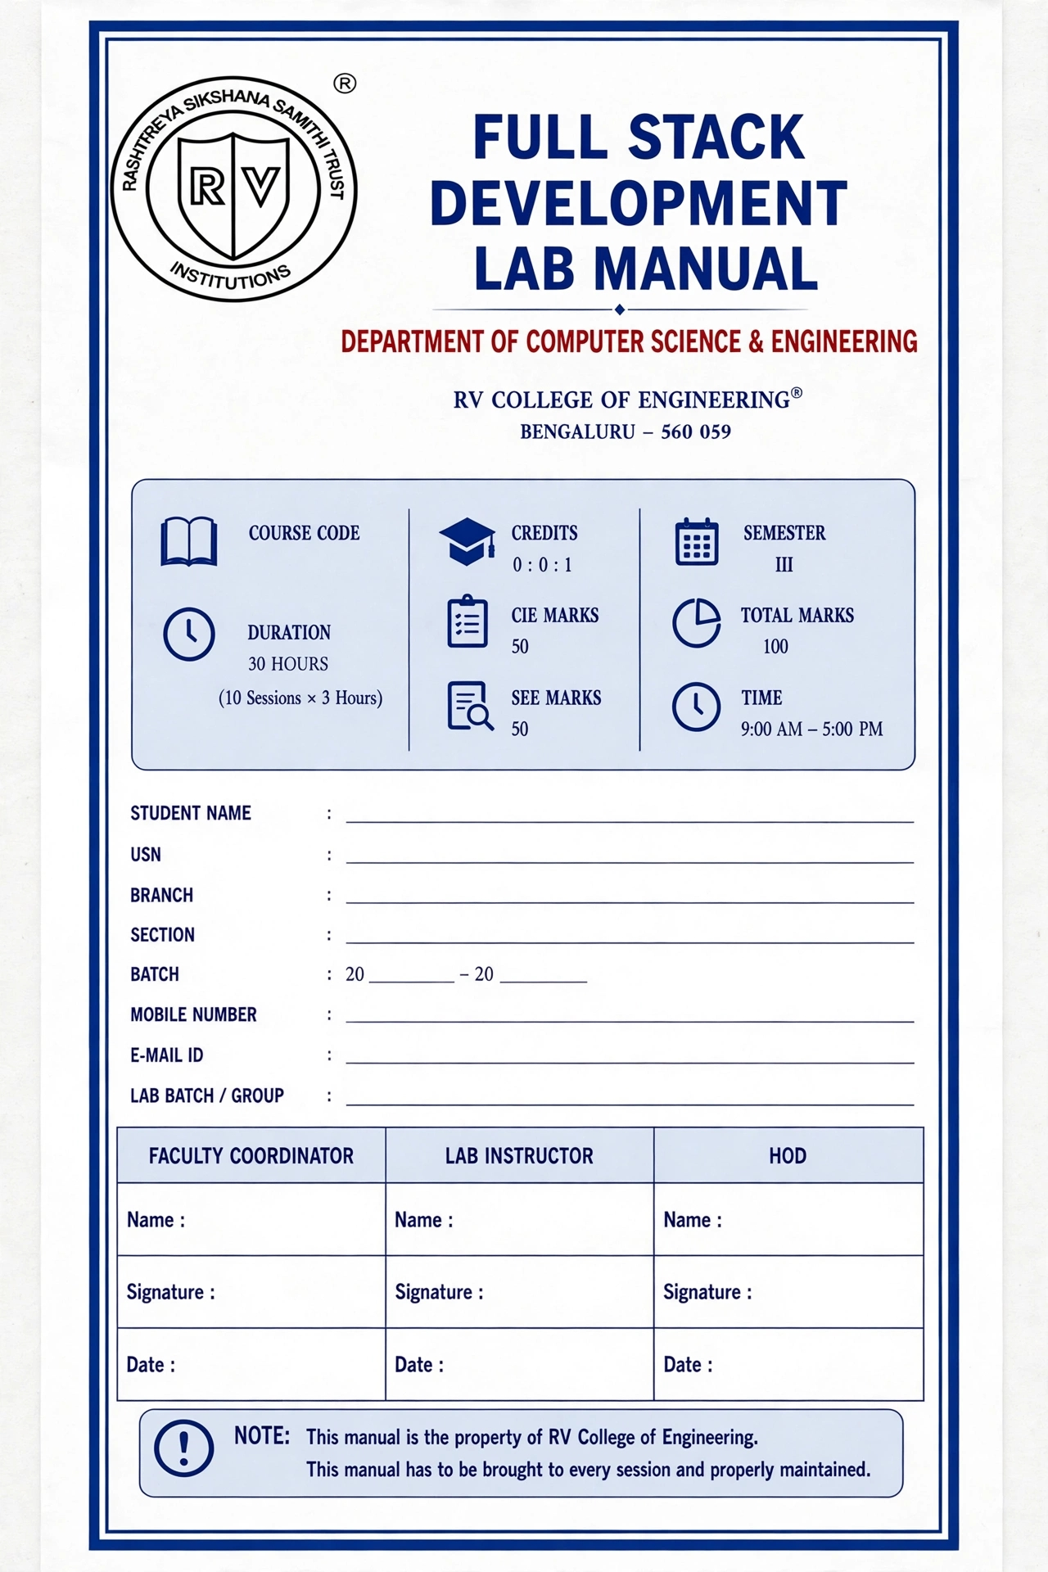


Go Change the World
RV College of Engineering®, Bengaluru
(Autonomous Institution affiliated to VTU, Belagavi)
Department of Computer Science and Engineering

Skill Lab: Full Stack Development

CERTIFICATE
This is to certify that Mr. /Ms. _______________, bearing USN , studying in I/II Semester, Department of , has successfully completed the Full Stack Development Skill Lab conducted by the Department of Computer Science and Engineering, RV College of Engineering®, Bengaluru, during the academic year 20 – 20 .
The student has satisfactorily completed 30 hours of hands-on skill training, including web fundamentals (HTML, CSS, JavaScript and client–server architecture); front-end development using React.js; back-end development using Node.js and Express.js; database management using MySQL and MongoDB; full stack integration through REST APIs, authentication and authorization; software testing, debugging, version control using Git/GitHub, web security, deployment and a capstone project involving the design, development, testing and deployment of a complete full stack web application.
The student has maintained the required Skill Lab Record/Manual, completed the assigned practical activities, and demonstrated satisfactory competency in design, development, testing and deployment of a complete full stack web application.
The performance of the student during the Skill Lab has been evaluated through Continuous Internal Evaluation (CIE) and Semester End Evaluation (SEE).

Computer Science & Engineering

Faculty Coordinator | Lab Instructor | HoD/ Program Coordinator
Signature: _____________ | Signature: _____________ | Signature: _____________
Date: _________________ | Date: _________________ | Date: _________________

FULL STACK DEVELOPMENT
SECOND Year (ODD SEM)LAB MANUAL
DEPARTMENT OF COMPUTER SCIENCE & ENGINEERING
RV College of Engineering®, Bengaluru

(Autonomous Institution affiliated to VTU, Belagavi)

Department of Computer Science & Engineering

Basic Skill Lab: Full Stack Development

CONTENTS
- About the Skill Lab
- Training Schedule
- Course Information
- Laboratory Rules and Safety Guidelines
- CIE & SEE Evaluation Scheme
- Skill Lab Module -1 - Web Development Foundations & Git
- Skill Lab Module -2 - JavaScript & Interactive Frontend
- Skill Lab Module -3 - Backend Development with Node.js & Express
- Skill Lab Module -4 - Database Integration & Full-Stack Integration
- Skill Lab Module -5 - GitHub, Team Collaboration & Capstone Project

About the Full Stack Development Skill Lab

Introduction
Full Stack Development is the process of designing, developing, and maintaining both the front end and back end of a web application. The front end focuses on the user interface and user experience using technologies such as HTML, CSS, JavaScript, and React.js, while the back end handles application logic, server-side processing, APIs, authentication, and communication with databases using technologies such as Node.js and Express.js. Database systems such as MySQL and MongoDB are used to store, manage, and retrieve application data.
Full Stack Development integrates these components to create complete, interactive, secure, and scalable web applications. It involves understanding client–server architecture, RESTful APIs, database integration, software testing, version control, and application deployment. By learning full stack development, students gain practical skills to build end-to-end web solutions, from designing responsive user interfaces to implementing server-side functionality and deploying applications for real-world use.

Objectives
The primary objective of Full Stack Development is to equip students with the knowledge and practical skills required to design, develop, test, and deploy complete web applications. It aims to develop proficiency in front-end technologies, back-end programming, database management, API integration, authentication, security, version control, and deployment. It also encourages problem-solving, modular design, debugging, and the development of responsive, reliable, and scalable web solutions to address real-world requirements.
- Significance of Full Stack Development
Full Stack Development is significant because it enables developers to understand and manage the complete lifecycle of a web application, from user interface design to server-side processing and data storage. It promotes seamless integration between application components, improves development efficiency, simplifies troubleshooting, and supports scalable and maintainable software solutions. The combination of front-end, back-end, and database skills also enhances collaboration across development teams and prepares students for diverse roles in the software industry.
- Applications of Full Stack Development
Full Stack Development is widely used to build dynamic websites and web applications across various domains, including e-commerce platforms, online banking, healthcare management systems, learning management systems, student information portals, social networking applications, online booking systems, inventory management, and job placement portals. It also supports the development of cloud-based applications, content management systems, real-time dashboards, and business automation platforms by integrating user interfaces, server-side logic, databases, and external services into unified solutions.

Top of Form
Bottom of Form

Training Schedule
First Year Basic Engineering Skills- WEB Essentials
Department of Computer Science and Engineering
(Time: 9:00 AM – 5:00 PM)

 |  | Morning Session | Afternoon Hands-on
Day | Date | Module | Practical Activities | Hours
1 | 22 OCT 2026 | Web fundamentals, HTML, CSS, responsive design | Portfolio + Git basics | 3+3 Hours
2 | 23 OCT 2026 | JavaScript, DOM, JSON, APIs | Interactive Task Manager | 3+3 Hours
3 | 24 OCT 2026 | Node.js, Express, REST API | Student REST API + Postman | 3+3 Hours
4 | 27 OCT 2026 | MongoDB + database integration | Full-stack Student Management App | 3+3 Hours
5 | 28 OCT 2026 | GitHub, branching, collaboration  *Hackathon* | Capstone development, testing & demo | 3+3 Hours

Semester: III/IV
FULL STACK DEVELOPMENT
Course Code | : |  |  | CIE | 50 Marks
Credits: L:T:P | : | 0 : 0: 1 |  | SEE | 50 Marks
Total Hours | : | 30 |  | SEE Duration | 60 min
Session | Theory | Practical / hands-on activity
1 | Web fundamentals, HTML, CSS and responsive design | Responsive profile website
2 | Portfolio development and Git basics | Portfolio publishing and Git repository
3 | JavaScript, DOM, JSON and APIs | Interactive task manager
4 | Node.js, Express and REST APIs | Student REST API with Postman
5 | MongoDB and database integration | Database-backed Student API
6 | React and full-stack integration | Full-stack Student Management App
7 | GitHub branching and collaboration | Team-based feature development and pull requests
8 | Testing, deployment and project presentation | Capstone development, deployment and demo

Capstone project:

Theory session
Topics covered
- Requirements analysis and user stories.
- Application architecture and database schema design.
- UI wireframes, component design and API contracts.
- Functional, integration and end-to-end testing.
- Debugging, validation, security and error handling.
- Deployment of front-end and back-end services.
- Environment configuration, project documentation and demonstration techniques.
Teaching activities
- Review a sample application's architecture and requirements.
- Demonstrate testing of successful, invalid and boundary-case inputs.
- Discuss deployment readiness, security checks and evaluation criteria.

Practical session
Activity: Develop and demonstrate a capstone web application
- Select a real-world problem, such as placement tracking, appointment booking, inventory management or an online quiz system.
- Prepare requirements, user stories and wireframes.
- Design the database and REST API endpoints.
- Develop the front end and back end, and integrate the database.
- Test CRUD operations, input validation, error handling and application workflows.
- Track work through GitHub and maintain project documentation.
- Deploy the application to suitable hosting services.
- Demonstrate the application, explain design decisions and respond to questions.
Deliverable: A deployed, tested and documented full-stack application with a GitHub repository and final demonstration.

Course Outcomes
CO1 | Explain the fundamental concepts of full stack web development, including client-side technologies, server-side technologies, and database systems.
CO2 | Apply HTML, CSS, JavaScript, and modern front-end frameworks to design and develop responsive and interactive web applications.
CO3 | Design and develop server-side applications and RESTful APIs using appropriate back-end technologies and frameworks.
CO4 | Develop and integrate full stack web applications by connecting front-end interfaces, back-end services, and databases using suitable technologies.
CO5 | Test, debug, deploy, and maintain full stack web applications by following secure coding practices and industry standards
Reference Books
1 | Jon Duckett, HTML and CSS: Design and Build Websites, 2011, Wiley, ISBN:9781118008188
2 | Jon Duckett, JavaScript and JQuery: Interactive Front-End Web Development, 2014, Wiley, ISBN:9781118531648.
3 | Jennifer Robbins, Learning Web Design, 5th Edition, 2018, O'Reilly Media, ISBN:9781491960202.
4 | Node.js Design Patterns — Mario Casciaro and Luciano Mammino, 3rd Edition, 2020, Packt Publishing, 978-1-83921-411-0
5. | Martin Krause,The Complete Developer, 2024, ISBN-13: 9781718503281

Rubric for the Continuous Internal Evaluation
 | Components | Marks
1 | Training Report Preparation: Evaluation based on report organization, technical content, documentation quality, observations, analysis, and timely submission. | 10
2 | Training Skill Demonstration: Assessment of practical skills, tool handling, safety practices, task execution, problem-solving ability, and active participation during training. | 20
3 | External Exhibition Evaluation: Assessment based on exhibit quality, innovation, technical understanding, presentation skills, demonstration, and response to evaluators' questions. | 20

Laboratory Rules
- Use the assigned computer system, peripherals, and software responsibly throughout every laboratory session.
- Maintain discipline, cleanliness, and a professional learning environment in the computer laboratory.
- Eating, drinking, and unnecessary movement inside the laboratory are strictly prohibited.
- Switch on and shut down the computer system only by following the prescribed procedure.
- Install or modify software only with the permission of the laboratory instructor.
- Create and save all web development files in the designated folder using appropriate file names and directory structures.
- Follow coding standards and maintain proper indentation, comments, and formatting while developing HTML, CSS, and JavaScript programs.
- Verify the correctness of HTML and CSS code using online validators before submitting the practical exercise.
- Test and debug web pages using browser developer tools to identify and resolve syntax, layout, and runtime errors.
- Record all program codes, observations, outputs, debugging results, and screenshots systematically in the Skill Lab Manual.
- Ensure that all practical activities, assignments, and mini-projects are completed individually unless group work is specifically instructed.
- Do not change system settings, install unauthorized applications, or access restricted websites during laboratory sessions.
- Log out of all online accounts, including GitHub and other web services, before leaving the laboratory.
- Switch off the computer, monitor, and other peripherals properly after completing the practical session.
- Keep the workstation clean and arrange all accessories properly before leaving the laboratory.

RV College of Engineering®, Bengaluru
(Autonomous Institution affiliated to VTU, Belagavi)

Department of Computer Science & Engineering
Full Stack Development
SCHEME OF CONDUCT & EVALUATION
Sl. No. | Exercises | No. of classes | Max. Marks | Marks Obtained
CIE
1 | Web fundamentals, HTML, CSS and responsive design | 1 | 20
2 | JavaScript, DOM, JSON and APIs | 1 | 20
3 | Node.js, Express and REST APIs | 1 | 20
4 | MongoDB and database integration | 1 | 20
5 | React and full-stack integration | 1 | 20
6 | GitHub branching and collaboration | 1 | 20
7 | Testing, deployment and project presentation | 1 | 30
CIE Test (Total Marks 150 reduce it to 50) |  |  | 50
Total

SEE Evaluation:

Component | Maximum Marks | Marks Obtained
Project | 10
Skill Demonstration | 20
Mini Project | 20
Total | 50

Internal Examiner External Examiner

SKILL LAB MODULE-1
Web Development Fundamentals, HTML, CSS, Responsive Design and Git

1. Aim
To develop a foundation in front-end web development by creating structured HTML pages, styling them with CSS, designing responsive layouts, and managing the project using basic Git version control.

2. Learning Objectives
- Explain the basic working of web applications and the roles of HTML, CSS and JavaScript.
- Create structured webpages using HTML5 document structure and commonly used elements.
- Apply CSS using selectors, the box model and reusable styling rules.
- Create flexible layouts using Flexbox and adapt them to different viewport sizes using media queries.
- Use browser developer tools to inspect and debug HTML/CSS.
- Apply basic Git operations for repository creation, staging, commits, history, branches and merging.

3. Introduction to Web Development
Web development is the process of creating applications that are accessed through a web browser. A browser (client) requests a resource from a web server, and the server returns the required content. A full-stack application typically contains a front end, a back end and a data-storage layer.

Layer | Role | Typical Technologies
Front end | User interface displayed in the browser | HTML, CSS, JavaScript
Back end | Application logic, authentication and APIs | Server-side languages/frameworks
Database | Stores and retrieves application data | Relational or NoSQL databases

In this module, emphasis is placed on the front-end foundation—HTML, CSS and responsive design, followed by Git for version control.

Full-stack development is an end-to-end approach to building web applications that integrates the frontend, backend, database, and application programming interfaces (APIs) into a unified system. As shown in the Figure 1, the frontend provides the user interface and manages user interaction, while the backend implements application logic, processes client requests, and communicates with databases and other services. Databases are responsible for storing and retrieving application data, while APIs enable communication between different components of the application. Full-stack development therefore provides an understanding of how a web application operates as a complete system, from user interaction in the browser to server-side processing and data management. Modern full-stack applications commonly follow a layered architecture in which the client communicates with backend services through HTTP/REST APIs, and the backend interacts with one or more databases.

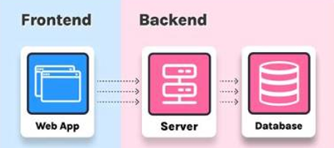
Figure 1: Overview of Full Stack Development

Client-Server Architecture
In a client-server architecture, the client requests a service or resource, while the server processes the request and returns an appropriate response as seen in the Figure 2.
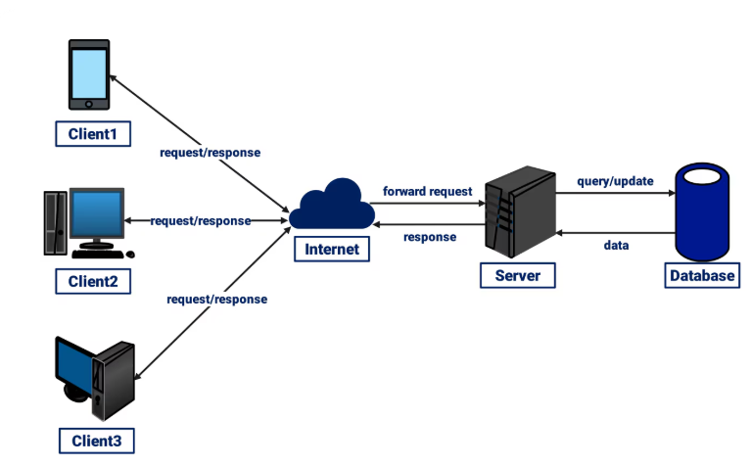
Figure 2: Client-Server Request Response Architecture

Request-Response Cycle
The request-response cycle describes how a client communicates with a server.
- The browser generates a request.
- The request is sent to the server.
- The server processes the request.
- The server may access a database.
- The server generates a response.
- The response is returned to the browser.
- The browser renders the received content.

Tasks to be Performed
- Open Developer Tools and select the Network tab.
- Open a webpage and reload it.
- Select an HTML document request.
- Identify request URL, request method, status code, and response.
- Identify requests for HTML, CSS, JavaScript, and images.
- Explain the sequence of communication between browser and server.

Tools and Software Required
Sl. No | Tool / Software | Purpose
1 | Visual Studio Code | Web development and code editing
2 | Git | Version control
3 | Node.js | JavaScript runtime and development environment
4 | Web Browser | Running and testing web pages
5 | Browser Developer Tools | Inspecting HTML, CSS, JavaScript and network requests
6 | HTML5 | Web page structure
7 | CSS3 | Basic presentation and font styling

4. HTML Fundamentals
HTML (HyperText Markup Language) is the standard markup language used to structure webpage content. An HTML document contains a head section for page information and a body section for visible content.

4.1 Basic HTML5 Document Structure
<!DOCTYPE html>
<html lang="en">
<head>
<meta charset="UTF-8">
<meta name="viewport" content="width=device-width, initial-scale=1.0">
<title>My Web Page</title>
</head>
<body>
<h1>Welcome</h1>
<p>This is a basic HTML5 page.</p>
</body>
</html>

4.2 Common HTML Elements
Element | Purpose | Example
<h1>...<h6> | Headings | <h1>Full Stack Development</h1>
<p> | Paragraph | <p>Welcome to the course.</p>
<a> | Hyperlink | <a href='about.html'>About</a>
<img> | Image | <img src='logo.png' alt='Logo'>
<ul>, <ol>, <li> | Lists | <ul><li>HTML</li></ul>
<table> | Tabular data | <table>...</table>
<form> | Collects user input | <form>...</form>
<div> / <span> | Generic containers | <div class='card'>...</div>

4.3 Semantic HTML
Semantic elements describe the meaning of page sections and improve readability and maintainability. Common elements include <header>, <nav>, <main>, <section>, <article> and <footer>.

4.4 Forms
Forms collect user input using controls such as text fields, email fields, radio buttons, checkboxes, select lists and buttons. Labels should be associated with controls, and HTML5 validation attributes such as required, min, max and pattern may be used.
<form>
<label for="email">Email:</label>
<input type="email" id="email" required>
<button type="submit">Submit</button>
</form>

5. HTML Lab Exercise
Create a single-page Student Profile / Course Information webpage using semantic HTML5. Create index.html using the standard HTML5 document structure. Add a header containing the page title and a navigation section with internal links. Create sections containing headings, paragraphs, a list, an image with meaningful alt text, and a small table. Add a simple form containing name, email, course selection and a submit button. Use labels and appropriate HTML5 input types.
Open the page in a browser, verify links and form controls, and inspect the document using browser developer tools.

Expected Result
A correctly structured HTML5 webpage containing semantic sections, text, links, media, tabular content and a basic form.

6. CSS Fundamentals
CSS (Cascading Style Sheets), as seen in the Figure 3,defines how HTML content is presented, sized, spaced and aligned. A CSS rule consists of a selector and a declaration block.
selector {
property: value;
}
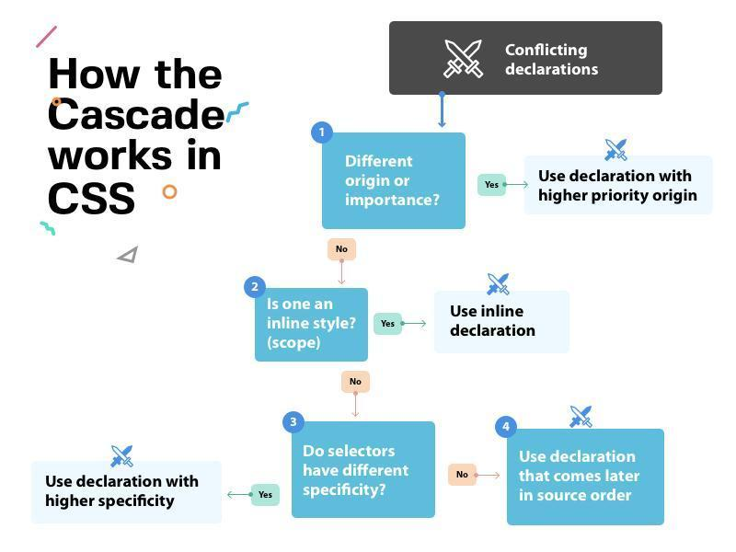
Figure 3: Cascading in CSS

6.1 Applying CSS
Method | Mechanism | Suitable Use
Inline | style attribute on an element | Small demonstrations
Internal | <style> block in the HTML file | Single-page prototypes
External | Separate .css file linked using <link> | Maintainable applications

External CSS is preferred for maintainable projects because one stylesheet can be reused across pages.

6.2 Essential Selectors
Selector | Example | Purpose
Element | p | Targets elements by type
Class | .card | Targets reusable components
ID | #main | Targets a uniquely identified element
Descendant | .card p | Targets matching descendants
Child | .card > p | Targets direct children
Attribute | input[type='email'] | Targets by attribute
Pseudo-class | button:hover | Targets a state/condition

7. CSS Box Model
Every rendered HTML element occupies a rectangular box consisting of content, padding, border and margin. Padding creates internal spacing, while margin creates external spacing.
Component | Meaning | Typical Properties
Content | Actual text, image or child content | width, height
Padding | Space between content and border | padding
Border | Boundary around padding/content | border
Margin | Space outside the border | margin

7.1 Box Sizing and Responsive Dimensions
With content-box, padding and border are added to the declared width. With border-box, the declared width includes content, padding and border. Using border-box generally makes component sizing easier to manage.
*, *::before, *::after { box-sizing: border-box; }
.container {
width: 92%;
max-width: 1200px;
margin: 0 auto;
}
img { max-width: 100%; height: auto; }

8. CSS Flexbox
Flexbox is a one-dimensional layout model for arranging related items in a row or column. The parent is the flex container and its direct children are flex items.
Property | Role
display: flex | Creates a flex formatting context
flex-direction | Sets row or column direction
justify-content | Distributes items along the main axis
align-items | Aligns items along the cross axis
flex-wrap | Allows items to move onto additional lines
gap | Creates consistent spacing
flex | Controls item grow, shrink and basis

.cards {
display: flex;
flex-wrap: wrap;
gap: 20px;
}
.card { flex: 1 1 260px; }

9. Responsive Web Design
Responsive web design enables a page to adapt to different screen sizes. It combines flexible dimensions, responsive media, layout systems such as Flexbox, and media queries. A mobile-first approach defines the compact layout first and adds rules for larger viewports.

9.1 Media Queries
header {
display: flex;
flex-direction: column;
gap: 15px;
}
@media (min-width: 768px) {
header {
flex-direction: row;
align-items: center;
justify-content: space-between;
}
}

9.2 Responsive Design Guidelines
- Prefer relative or flexible dimensions instead of unnecessary fixed widths.
- Use max-width to prevent content from becoming excessively wide.
- Use max-width: 100% and height: auto for responsive images.
- Use Flexbox wrapping and gap for adaptable component groups.
- Test narrow, medium and wide viewports using browser developer tools.
- Check for horizontal overflow, clipped content and inaccessible controls.

10. Integrated HTML + CSS + Responsive Design Exercise
Extend the HTML webpage created earlier into a responsive course webpage. Move presentation rules to an external style.css file. Apply element, class and pseudo-class selectors; include hover/focus styling. Use padding, border, margin and box-sizing to create consistent components. Create a responsive header/navigatio and a set of at least three cards using Flexbox. Use flexible widths and responsive images. Add at least one media query that changes the layout between narrow and wider screens. Test the page at multiple viewport widths and correct any unnecessary horizontal scrolling.

Observation Table
Check | Observation
HTML structure and semantic elements
Selectors and states applied
Box model and spacing verified
Flexbox layout works correctly
Responsive behaviour verified

11. Result - HTML/CSS/Responsive Design
A structured and responsive webpage was developed using HTML5, CSS selectors, the box model, Flexbox and media queries, and was tested at different viewport sizes.

12. Viva Voce - HTML/CSS/Responsive Design
- What is the role of HTML in a webpage? What is meant by semantic HTML?
- What is the difference between a class selector and an ID selector?
- Explain content, padding, border and margin in the CSS box model.
- What is the difference between content-box and border-box?
- What are the main axis and cross axis in Flexbox?
- What is responsive web design and why are media queries used?

13. Git Fundamentals
Version control tracks and manages changes made to project files over time. It helps maintain project history, restore earlier versions, work on features independently and support collaboration.

13.1 Git and GitHub
Git | GitHub
Distributed version control system | Online platform for hosting Git repositories
Installed and used locally | Accessed through the Internet
Tracks changes and project history | Supports remote hosting and collaboration
Can work without Internet | Typically used for online collaboration

13.2 Git Repository and Workflow
A repository stores the history of a project. Running git init creates a hidden .git directory. The working directory contains current project files; the staging area contains changes selected for the next commit; the repository stores committed snapshots.
Working Directory -- git add --> Staging Area -- git commit --> Repository

13.3 Commit, Branch and Merge
A commit is a snapshot of the project's files at a particular point in time and normally includes a commit ID, author, date/time and commit message. A branch is an independent line of development. Merge combines changes from one branch into another.
git commit -m "Created responsive course page"
git branch feature
git checkout feature
git checkout main
git merge feature

14. Integrated Git Lab Exercise
Use the HTML/CSS project created in the previous exercise and perform the complete Git workflow.
Verify Git installation using git --version.
Open the project folder, initialize it using git init, and inspect the repository using git status.
Stage the project files and create the initial commit.
Modify the webpage, stage the change and create a second meaningful commit.
Display the compact commit history using git log --oneline.
Create a feature branch and switch to it.
Make one modification on the feature branch and commit it.
Switch back to main and merge the feature branch.

Core Commands
git --version
git init
git status
git add .
git commit -m "Initial responsive webpage"
git log --oneline
git branch feature
git checkout feature
git checkout main
git merge feature

Expected Observation
Git should show tracked/staged files, create commit IDs, display commit history, identify the active branch, and merge the committed feature changes into main.

15. Git Command Summary
Command | Purpose
git init | Initialize a Git repository
git status | Display repository status
git add | Add changes to the staging area
git commit | Save staged changes in repository history
git log --oneline | Display compact commit history
git branch | Create or list branches
git checkout | Switch between branches
git merge | Combine changes from branches

16. Git Observation Table
Operation | Command | Observation
Initialize repository | git init
Check status | git status
Stage files | git add .
Commit changes | git commit
View history | git log --oneline
Create/switch branch | git branch / git checkout
Merge branch | git merge feature

17. Result - Git
The web project was maintained using Git by initializing a repository, staging and committing changes, viewing history, creating and switching branches, and merging a feature branch.

18. Skill Assessment Activity
Create a responsive webpage titled “My Full Stack Project”. The page must use semantic HTML, an external stylesheet, Flexbox, responsive sizing and at least one media query. Initialize the project as a Git repository, create at least two meaningful commits, create a feature branch, commit one change on that branch and merge it into main. Submit the source files and evidence of the Git commit history.

19. Viva Questions
- What is the role of HTML, CSS, and JavaScript in a web application?

- What is the difference between front-end and back-end development?

- Why do we use <!DOCTYPE html> at the beginning of an HTML document?

- What is the difference between an id and a class in HTML?

- What are semantic HTML elements? Give any two examples.

- If the same CSS property is specified using inline, internal, and external CSS, which one normally gets higher priority?

- What is the CSS box model? Name its four components.

- What is the difference between margin and padding?

- Why might a webpage that looks correct on a laptop appear improperly on a mobile phone?

- What is Responsive Web Design, and why is it required?

- What does box-sizing: border-box change in the above calculation?

- What is the difference between display: none and visibility: hidden?

- What is Flexbox? When would you use it?

- What is the difference between justify-content and align-items in Flexbox?

- What is the difference between CSS Grid and Flexbox?

- How can you display an element on a desktop but hide it on a mobile device?

- What is the difference between position: relative and position: absolute?

- What happens if two CSS selectors contain conflicting styles for the same element? How does the browser decide which one to apply?

- What is Git, and why do developers use it?

- What is the difference between Git and GitHub?

SKILL LAB MODULE-2

JavaScript & Interactive Frontend

JavaScript is a programming language used to make web pages interactive and dynamic. While HTML provides the structure and CSS provides presentation, JavaScript enables the webpage to respond to user actions, manipulate content, validate input, process data, communicate with APIs, and store information.
This skill lab introduces students to JavaScript fundamentals and provides hands-on experience in developing interactive frontend applications. Students will progressively learn JavaScript concepts, DOM manipulation, event handling, JSON processing, API consumption, browser storage, and Git-based development.

Learning Outcomes
- Use JavaScript variables, data types, operators, conditions, loops, functions, arrays, and objects.
- Manipulate HTML elements dynamically using the DOM.
- Handle user interactions using JavaScript events.
- Develop dynamic web pages with form validation, searching, filtering, and table generation.
- Store and retrieve data using browser Local Storage.
- Parse and process JSON data using JavaScript.
- Consume a REST API using the fetch () method.
- Develop a small interactive frontend application.
- Use Git branches, commits, push, and merge operations for collaborative development.

Getting Started

Prerequisites
- Basic HTML (headings, forms, tables, input fields) and basic CSS (selectors, colours, layout).
- Ability to create, save and organise files in a project folder.

Tools Required
- Visual Studio Code with the Live Server extension.
- A modern browser such as Chrome or Edge, with its Developer Tools.
- Git (run git --version in a terminal to confirm it is installed).

Setting Up Your Workspace
Create a folder named js-skill-lab and open it in VS Code. Keep each experiment in its own subfolder (for example exp1, exp2) containing index.html and script.js. Link the script just before the closing </body> tag using <script src="script.js"></script>. Right-click index.html and choose Open with Live Server to run it. Always use Live Server rather than double-clicking the file, because browsers block fetch () requests for local files opened through file://.

Using the Browser Console
Press F12 (or Ctrl+Shift+I) in the browser to open Developer Tools. The Console tab shows console.log () output and error messages, the Elements tab shows the live DOM, and the Application tab lets you inspect Local Storage.

Use Git from the Start
Version control is used throughout the lab, not only at the end. Initialise a repository in your project folder now and commit after completing each experiment. Module 6 covers branches, remotes and merging in detail.
git init
git add .
git commit -m "Complete Experiment 1"

1: JavaScript Fundamentals

1.1 Introduction to JavaScript
JavaScript is a high-level, interpreted programming language primarily used to add behavior and interactivity to web pages.

Table 1: Web Technologies
Technology | Purpose
HTML | Structure and content
CSS | Appearance and layout
JavaScript | Behavior and interactivity

JavaScript can be included in an HTML document using the <script> element.

Example: Your First Script
<!DOCTYPE html>
<html>
<head>
<title>JavaScript Example</title>
</head>
<body>
<h2 id="message">Welcome</h2>
<script>
document.getElementById("message").textContent = "Welcome to JavaScript!";
</script>
</body>
</html>

1.2 Variables
Variables are used to store data.
let name = "Anita";
const age = 20;
var college = "ABC College";
let is generally used for variables whose values may change, while const is used for values that should not be reassigned.
var is the older way of declaring variables. It is function-scoped and can be redeclared accidentally, which often causes bugs, so this lab uses let and const only.

1.3 Data Types
Common JavaScript data types include:
- Number
- String
- Boolean
- Undefined
- Null
- Object
- Array

let studentName = "Rahul";
let marks = 85;
let passed = true;
let result = null;

Template Literals
Template literals are written with backticks (`) instead of quotes. They let you embed variables and expressions inside ${ } and can span multiple lines.
let name = "Anita";
let marks = 85;
console.log(`${name} scored ${marks} marks`);

Taking Input and Showing Output
Input can be read with prompt (), which always returns text, or from an input field using its value property. Convert text to a number with Number (). Output can be shown with console.log (), alert (), or by writing into an element on the page using textContent.

let marks = Number(prompt("Enter marks:"));
let field = document.getElementById("marksInput"); // <input id="marksInput">
let value = Number(field.value);
document.getElementById("output").textContent = "Marks: " + marks;

Experiment 1: Student Details
Task: Write a JavaScript program to store and display the Student name, USN, Branch, Semester, Marks, and Pass/Fail status.
Rules: Marks are out of 100. The status is Pass if marks are 40 or above, otherwise Fail. Read the values using prompt () or input fields and display the result on the web page inside a <div id="output">, not only in the console.

1.4 Operators
JavaScript supports several types of operators.

Arithmetic Operators
let a = 10;
let b = 3;
console.log(a + b);
console.log(a - b);
console.log(a * b);
console.log(a / b);
console.log(a % b);

Comparison Operators
a == b
a === b
a != b
a !== b
a > b
a < b
a >= b
a <= b
Prefer === and!== in your programs. The == operator converts types before comparing, so "5" == 5 is true, whereas === compares both value and type, so "5" === 5 is false.

Logical Operators
&& // AND
|| // OR
! // NOT

1.5 Conditional Statements
let marks = 75;
if (marks >= 50) {
console.log("Pass");
} else {
console.log("Fail");
}

Multiple Conditions
if (marks >= 90) {
console.log("A+");
} else if (marks >= 75) {
console.log("A");
} else if (marks >= 60) {
console.log("B");
} else {
console.log("C");
}

1.6 Loops

For Loop
for (let i = 1; i <= 5; i++) {
console.log(i);
}

While Loop
let i = 1;
while (i <= 5) {
console.log(i);
i++;
}

1.7 Functions
Functions are reusable blocks of code.
function add(a, b) {
return a + b;
}
let result = add(10, 20);
console.log(result);

2. Arrow Function
const multiply = (a, b) => a * b;

Experiment 2: Marks Calculator
Task: Develop a JavaScript program that accepts marks of five subjects and calculates Total marks, Average, Percentage, and Grade.
Rules: Each subject is out of 50 marks, so the maximum total is 250. Average = Total / 5 and Percentage = Total / 250 × 100. Grade: A+ for 90% and above, A for 75–89%, B for 60–74%, C for 40–59%, and F below 40%. Read the marks from input fields and show all results on the web page.

2.1 Arrays
An array stores multiple values in a single variable.
let subjects = ["DSA", "DBMS", "Java", "Web Technology"];
console.log(subjects[0]);
console.log(subjects.length);
Common array methods include:
push(), pop(), shift(), unshift(), forEach(), map(), filter(), find(), findIndex(), splice()
let marks = [70, 85, 90, 65];
marks.forEach(function(mark) {
console.log(mark);
});

map() and filter()
map() creates a new array by transforming every element. filter() creates a new array containing only the elements that satisfy a condition.
let marks = [70, 85, 90, 65];
let bonus = marks.map(m => m + 5); // [75, 90, 95, 70]
let high = marks.filter(m => m >= 75); // [85, 90]

Finding and Removing Items
find() returns the first matching element, findIndex() returns its position (or -1 if not found), and splice(index, count) removes elements from the array. These methods are needed to implement Edit and Delete.
let students = [{usn: "1RV23CS001", name: "Anita"}, {usn: "1RV23CS002", name: "Rahul"}];
let s = students.find(x => x.usn === "1RV23CS002"); // the Rahul object
let i = students.findIndex(x => x.usn === "1RV23CS002"); // 1
students.splice(i, 1); // removes Rahul

2.2 Objects
Objects store data using key-value pairs.
let student = {
name: "Anita",
usn: "1RV23CS001",
semester: 5,
branch: "CSE"
};
console.log(student.name);
console.log(student.usn);

2.3 DOM Manipulation
DOM stands for Document Object Model. The DOM represents an HTML document as a tree of objects. JavaScript can access and modify these objects.

Selecting an Element
document.getElementById("title");
Other methods include:
document.querySelector()
document.querySelectorAll()

Changing Content
document.getElementById("title").textContent = "Hello Students";

Changing Style
document.getElementById("title").style.color = "blue";

Creating an Element
let p = document.createElement("p");
p.textContent = "This paragraph was created using JavaScript.";
document.body.appendChild(p);

Experiment 3: DOM Manipulation
Task: Create a webpage containing a heading and paragraph. Add three buttons: Change heading, Change paragraph, and Change background. Use JavaScript DOM manipulation to implement the functionality.

3: Events and Dynamic Web Pages

3.1 JavaScript Events
An event represents an action that occurs on a webpage.
- click
- submit
- change
- input
- mouseover
- keydown

Event Handling
<button id="btn">Click Me</button>
<script>
document.getElementById("btn").addEventListener("click", function() {
alert("Button clicked!");
});
</script>

Input Event
document.getElementById("name").addEventListener("input", function() {
console.log(this.value);
});
Inside a regular function used as an event handler, this refers to the element that received the event, so this.value is the text currently in the input. An arrow function does not have its own this, so use event.target.value instead:
document.getElementById("name").addEventListener("input", (event) => {
console.log(event.target.value);
});

Form Submit Event
document.getElementById("studentForm")
.addEventListener("submit", function(event) {
event.preventDefault();
console.log("Form submitted");
});
The preventDefault() method prevents the browser's default form submission behavior.

3.2 Validating Input
Validation checks that input follows the expected rules before it is used. Useful string tools are trim() (removes surrounding spaces) and length. For patterns such as an email address or mobile number, use a regular expression (regex) with its test() method, which returns true or false.
let name = " Anita ";
console.log(name.trim().length > 0); // true
let mobilePattern = /^\d{10}$/; // exactly 10 digits
console.log(mobilePattern.test("9876543210")); // true
let emailPattern = /^[^\s@]+@[^\s@]+\.[^\s@]+$/;
console.log(emailPattern.test("anita@example.com")); // true

Experiment 4: Form Validation
Objective: Develop a student registration form and validate user input using JavaScript.
The form should contain:
- Name
- Email
- Mobile Number
- Password
- Confirm Password

Validation Rules:
- Name should not be empty.
- Email should be in valid format.
- Mobile number should contain 10 digits.
- Password should have minimum 8 characters.
- Password and confirm password should match.

Expected Result: Display appropriate validation messages without submitting the form when invalid data is entered.
Display each message in a <span class="error"> placed next to its field, styled in red, and clear the message as soon as the field becomes valid.

Experiment 5: Dynamic Table Generation
Objective: Create an HTML form that accepts student information and dynamically adds the information to a table.
Input: USN, Name, Branch, Semester, CGPA

HTML Structure
<input id="usn" placeholder="USN">
<input id="name" placeholder="Name">
<input id="branch" placeholder="Branch">
<input id="semester" type="number" placeholder="Semester">
<input id="cgpa" type="number" step="0.01" placeholder="CGPA">
<button id="addBtn">Add Student</button>
<table border="1" id="studentTable">
<thead>
<tr><th>USN</th><th>Name</th><th>Branch</th><th>Semester</th><th>CGPA</th></tr>
</thead>
<tbody id="studentBody"></tbody>
</table>

JavaScript
let students = [];
function renderTable(list) {
const body = document.getElementById("studentBody");
body.innerHTML = "";
list.forEach(function (s) {
const row = body.insertRow();
row.insertCell(0).textContent = s.usn;
row.insertCell(1).textContent = s.name;
row.insertCell(2).textContent = s.branch;
row.insertCell(3).textContent = s.semester;
row.insertCell(4).textContent = s.cgpa;
});
}
function addStudent() {
const student = {
usn: document.getElementById("usn").value.trim(),
name: document.getElementById("name").value.trim(),
branch: document.getElementById("branch").value.trim(),
semester: Number(document.getElementById("semester").value),
cgpa: Number(document.getElementById("cgpa").value)
};
if (!student.usn || !student.name) {
alert("USN and Name are required");
return;
}
students.push(student);
renderTable(students);
["usn", "name", "branch", "semester", "cgpa"].forEach(function (id) {
document.getElementById(id).value = ""; // clear the form
});
}
document.getElementById("addBtn").addEventListener("click", addStudent);
Notes: The button is wired with addEventListener() instead of an inline onclick attribute, which keeps HTML and JavaScript separate. The table is rebuilt from the students array by renderTable(), so the same function can later display search results. textContent is used so that anything typed by the user is shown as plain text.

Extension Tasks
- Add a Delete button for every row.
- Add an Edit button.
- Validate CGPA.
- Display the total number of students.
- Add a search option.

Experiment 6: Search/Filter Functionality
Objective: Extend Experiment 5 so that the student table can be searched, with the matching rows shown on the page (not only in the console). Add this search box above the table:
<input id="search" placeholder="Search by name">
// Sample data for testing (or use the students added in Experiment 5)
students = [
{usn: "1RV23CS001", name: "Anita", branch: "CSE", semester: 5, cgpa: 8.9},
{usn: "1RV23IS002", name: "Rahul", branch: "ISE", semester: 5, cgpa: 8.2},
{usn: "1RV23CS003", name: "Priya", branch: "CSE", semester: 3, cgpa: 9.1},
{usn: "1RV23EC004", name: "Arun", branch: "ECE", semester: 3, cgpa: 7.6}
];
renderTable(students);
function searchStudent() {
const text = document.getElementById("search").value.toLowerCase();
const result = students.filter(function (s) {
return s.name.toLowerCase().includes(text);
});
renderTable(result); // update the table on the page
}
document.getElementById("search").addEventListener("input", searchStudent);
Extension: Add a Branch drop-down, a Semester drop-down and a minimum-CGPA input, and combine them with the name search so that all selected conditions apply together.

Experiment 7: Button/Event Handling
Task: Create a webpage containing Add, Delete, Edit, Clear, and Search buttons. Use addEventListener() to handle the events.
Data: Keep a list of student names in an array and show it as an unordered list (<ul>). Add inserts the name typed in a text box, Delete removes an item, Edit changes an item's text using prompt(), Clear empties the list, and Search filters the list. Every action must update both the array and the displayed list.
Students should understand the relationship:
User Action → Event → JavaScript Function → DOM Update

4: Local Storage and JSON

4.1 Local Storage
Local Storage allows a webpage to store data in the browser.

Store Data
localStorage.setItem("studentName", "Anita");

Retrieve Data
let name = localStorage.getItem("studentName");
console.log(name);

Remove Data
localStorage.removeItem("studentName");

Store an Array/Object
let students = [
{name: "Anita", branch: "CSE"},
{name: "Rahul", branch: "ISE"}
];
localStorage.setItem("students", JSON.stringify(students));
Retrieve:
let data = JSON.parse(localStorage.getItem("students"));
console.log(data);

Experiment 8: Local Storage
Task: Extend the list from Experiment 7 so that it is saved in Local Storage every time it changes and is reloaded when the page opens. Local Storage stores only text, which is why JSON.stringify() and JSON.parse() are used. Confirm that the data survives a page refresh and inspect the stored value in the browser's Developer Tools (Application tab).

4.2 What is JSON?
JSON stands for JavaScript Object Notation. JSON is a lightweight format commonly used for exchanging data between applications.
{
"name": "Anita",
"usn": "1RV23CS001",
"branch": "CSE",
"semester": 5
}
A JSON array can contain multiple objects.
[
{"name": "Anita", "branch": "CSE"},
{"name": "Rahul", "branch": "ISE"}
]

4.3 JSON and JavaScript
JSON.parse()
JSON.stringify()

JSON String → JavaScript Object
let jsonData = '{"name":"Anita","branch":"CSE"}';
let student = JSON.parse(jsonData);
console.log(student.name);

JavaScript Object → JSON
let student = { name: "Anita", branch: "CSE" };
let jsonData = JSON.stringify(student);
console.log(jsonData);

4.4 From JSON to Web Page
JSON Data
↓
JSON.parse()
↓
JavaScript Object
↓
DOM Manipulation
↓
HTML Web Page

Experiment 9: JSON to Table
Task: Create a JSON dataset containing five students (name, USN, branch, semester). Keep it as a JSON string inside your script. If you prefer a separate students.json file, load it with fetch () and run the page through Live Server, because fetch () cannot read local files opened through file://. Then: (1) read the JSON data, (2) convert it into JavaScript objects using JSON.parse(), (3) iterate through the objects, (4) generate table rows dynamically, and (5) display the student information in a table.

5: Consuming an API

5.1 What is an API?
API stands for Application Programming Interface. A web API allows an application to communicate with another application or server and exchange data.
A commonly used method for requesting data from an API in JavaScript is fetch ().

Callbacks and Promises
A callback is a function passed to another function to be run later. fetch () does not return the data immediately. It returns a promise, an object that stands for a result that will arrive later. Use .then () to handle success and .catch () to handle failure. Arrow functions (such as response => response.json()) are commonly used inside .then().

5.2 Basic Fetch Syntax
fetch("API_URL")
.then(response => {
if (!response.ok) {
throw new Error("Request failed: " + response.status);
}
return response.json();
})
.then(data => console.log(data))
.catch(error => console.error(error));
The process is:
Web Page → fetch() → API Server → JSON Response → JavaScript → DOM → Web Page
Note: catch() runs only when the request itself fails (for example, no network). A 404 or 500 reply is still a completed request, so always check response.ok as shown above. The same logic can also be written with async/await:
async function loadData() {
try {
const response = await fetch("API_URL");
if (!response.ok) throw new Error("Request failed: " + response.status);
const data = await response.json();
console.log(data);
} catch (error) {
console.error(error);
}
}

5.3 Example
fetch("https://jsonplaceholder.typicode.com/users")
.then(response => response.json())
.then(users => {
users.forEach(user => {
console.log(user.name);
});
})
.catch(error => {
console.log("Error:", error);
});

5.4 Displaying API Data
<div id="users"></div>
<script>
fetch("https://jsonplaceholder.typicode.com/users")
.then(response => {
if (!response.ok) throw new Error("Request failed: " + response.status);
return response.json();
})
.then(users => {
let output = "";
users.forEach(user => {
output += `<div><h3>${user.name}</h3><p>${user.email}</p></div>`;
});
document.getElementById("users").innerHTML = output;
})
.catch(error => {
document.getElementById("users").textContent = "Could not load users: " + error.message;
});
</script>
Security note: innerHTML treats its value as HTML. It is acceptable here because the data comes from a known API for practice, but never assign untrusted data (such as text typed by a user) to innerHTML, as this can allow cross-site scripting (XSS). Prefer textContent or createElement() for untrusted data.

Experiment 10: Consuming an API
Objective: Fetch user data from the API and present it as a searchable table. Complete the following tasks.
- Display users in a table.
- Display name, email and city.
- Add a search box.
- Filter users based on name.
- Display an appropriate message if the API request fails (check response.ok as well as using catch).

6: Mini Project and Version Control

6.1 Mini Project: Student Task Manager
Develop a web-based Student Task Manager using HTML, CSS and JavaScript. The application should allow users to create and manage their tasks.

Required Features

1. Add Task
The user enters a task and clicks Add Task.

2. Delete Task
Each task should have a Delete button.

3. Mark Task as Completed
Users should be able to mark a task as completed.

4. Search/Filter
Provide options such as All, Pending, and Completed, along with a search box.

5. Local Storage
Tasks must remain available even after the webpage is refreshed.

Suggested Data Structure
let tasks = [
{ id: 1, title: "Complete JavaScript Lab", completed: false },
{ id: 2, title: "Prepare Assignment", completed: true }
];

Suggested Functions
addTask()
deleteTask()
toggleTask()
displayTasks()
searchTasks()
filterTasks()
saveTasks()
loadTasks()

Mini Project Requirements
- Have a user-friendly interface.
- Dynamically update the task list.
- Validate empty task entries.
- Allow tasks to be deleted.
- Allow tasks to be marked completed.
- Support searching/filtering.
- Persist tasks using Local Storage.
- Work correctly after refreshing the browser.

Styling Guidance
- Keep styles in a separate style.css file linked in the <head> of index.html.
- Centre the application in a container with a maximum width of about 600px and use consistent spacing.
- Place the task input and the Add Task button on one row (for example using display: flex).
- Show completed tasks differently (for example grey text with text-decoration: line-through).
- Add hover and focus styles for buttons and ensure text has sufficient contrast.

6.2 Git Activity
Work in teams of two or three. All members share one repository for the Mini Project; each member develops a different feature on a separate branch and merges it into main through a pull request.
Create Branch → Develop Feature → Commit → Push → Pull Request → Merge

Step 1: Create Repository
git init
or clone an existing repository:
git clone <repository-url>
Add a .gitignore file listing files that should not be tracked (for example .vscode/ and node_modules/), then make the first commit on the main branch:
git add .
git commit -m "Initial commit"
git branch -M main

Step 2: Create a Branch
git branch feature/add-task
git checkout feature/add-task
Alternatively:
git switch -c feature/add-task

Step 3: Develop Feature
Students implement one feature such as Add Task, Delete Task, Search Task, or Local Storage.

Step 4: Check Changes
git status

Step 5: Commit Changes
git add .
git commit -m "Add task creation feature"

Step 6: Push Branch
git remote add origin <repository-url> # once per repository, if you used git init
git push -u origin feature/add-task

Step 7: Merge
After the feature has been developed and reviewed, merge the feature branch into the main branch.
git checkout main
git merge feature/add-task

Step 8: Pull Request and Merge Conflicts
On GitHub, open a pull request from your feature branch into main and ask a team member to review it before merging. Afterwards, update your local copy of main. If two members change the same lines, Git reports a merge conflict: open the file, keep the correct lines between the <<<<<<<, ======= and >>>>>>> markers, delete the markers, then run git add and git commit to finish the merge.
git checkout main
git pull origin main

Suggested Git Activities
main
|-- feature/add-task
|-- feature/delete-task
|-- feature/search-task
|-- feature/local-storage

6.3 Lab Submission Requirements
- HTML files
- CSS files
- JavaScript files
- JSON data, if used
- Screenshots of the working application
- Git repository link
- Brief description of implemented features
7.Viva Questions
- What is JavaScript?
- Differentiate let, const, and var.
- What is the DOM?
- What is an event in JavaScript?
- What is the difference between == and ===?
- What is an array?
- What is a JavaScript object?
- What is JSON?
- What is the purpose of JSON.parse()?
- What is the purpose of JSON.stringify()?
- What is Local Storage?
- What is the purpose of fetch ()?
- What is an API?
- Why is prevent Default () used?
- What is Git branching?
- Why are commits used?
- What is the difference between git push and git pull?
- Why should different features be developed using separate branches

SKILL LAB MODULE-3

Introduction to Backend Development with Node.js and Express

1. Introduction to Backend Development
A web application generally consists of two major parts: frontend and backend. The frontend is the part visible to the user, while the backend works behind the scenes to process requests, apply logic, communicate with databases and provide data through APIs. Table 1 Describes the above.
Table 1: Contents of Frontend and Backend
Frontend | Backend
User interface, forms, menus and pages | Server-side processing and business logic
HTML, CSS, JavaScript, React, Angular | Node.js, Express and database services
Runs mainly in the browser | Runs on the server

Server-Side Programming
Server-side programming refers to programs that execute on the server rather than in the user's browser. The server receives requests, processes them and sends an appropriate response.

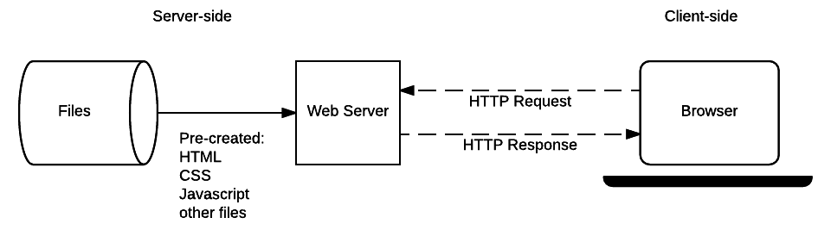

Figure 1: Server-Side Architecture

Figure 1, shows how a client request reaches server-side logic and how the server returns a response.
Client and Server
A client is a device or application that requests a service. A server receives the request and provides data or a service. Examples of clients include web browsers, mobile applications and Postman.
Client–Server Communication
The client sends an HTTP request containing information such as the URL and method. The server processes the request and returns a response containing a status code, headers and, when required, a response body.

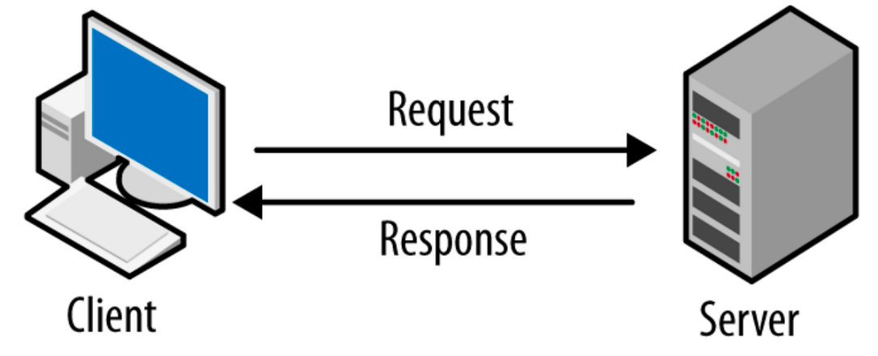

Figure 2: Client–Server Model

Figure 2 Illustrates communication between a client and a server through requests and responses.
Node.js
Node.js is a JavaScript runtime environment that allows JavaScript to run outside the web browser. It is used to create servers, develop APIs, handle HTTP requests, work with files and communicate with databases.
• JavaScript on the server – enables backend programming using JavaScript.
• Fast and efficient – designed to handle many requests efficiently.
• Event-driven – uses an event-driven programming model.
• Non-blocking I/O – can continue handling other operations while waiting for I/O tasks.
npm – Node Package Manager
npm is the default package manager for Node.js. It is used to initialize projects, install packages, update dependencies and manage the packages required by an application. Table 2 tells about the Node package manager.

Table 2: Node Package Manager
Command | Purpose
npm init -y | Creates package.json with default values
npm install <package> | Installs a package
npm uninstall <package> | Removes a package
npm update | Updates installed packages

HTTP Methods and CRUD
Table 3: HTTP Methods and CRUD
HTTP Method | Purpose | CRUD
GET | Retrieve data | Read
POST | Create new data | Create
PUT | Update existing data | Update
DELETE | Remove data | Delete
Important status codes include 200 OK, 201 Created, 400 Bad Request, 404 Not Found and 500 Internal Server Error.Table 3 Indicates various HTTP methods and CRUD.

2. Node.js Hands-on
Creating a Node.js Project
A Node.js project is a folder containing the source code and files required for an application.
1. Create a folder named node-demo.
2. Open the folder in Visual Studio Code.
3. Open Terminal → New Terminal.
4. Initialize the project using the command below.
npm init -y
The command creates package. json, which stores important project information such as project name, version, main file, scripts and dependencies.
Node.js Modules
A module is a reusable unit of code that provides specific functionality. Modules divide an application into smaller and manageable parts. Table 4 shows Module type along with Examples
Table 4: Module type and Examples
Module Type | Examples / Purpose
Built-in | http – server creation; fs – files; path – file paths; os – operating-system information
User-defined | Modules created by the developer for a specific application
External | Packages installed through npm

Basic Node.js Application
console.log ("Hello, Node.js!");
node app.js
Creating an HTTP Server
Node.js provides the built-in http module for creating web servers. The server listens on a port and sends a response when a client makes a request.
const http = require('http');
const server = http.createServer((req, res) => {
res.end("Welcome to Node.js Server");
});
server.listen(3000, () => {
console.log("Server running on port 3000");
});
Run the application using node app.js and open http://localhost:3000 in a browser.
Routing
Routing determines how a server responds to different URLs or paths. A server can check the requested URL and return an appropriate response.figure 3 shows the routing architecture.
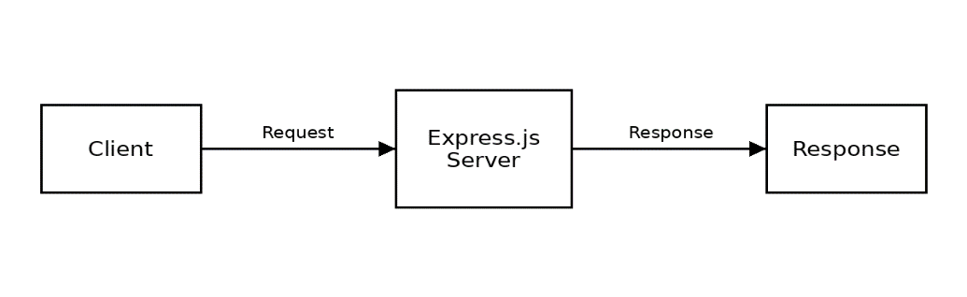
if (req.url === '/') {
res.end("Home Page");
} else if (req.url === '/about') {
res.end("About Page");
} else if (req.url === '/students') {
res.end("Student Page");
} else {
res.end("Page Not Found");
}

Figure 3: Routing Architecture

3. Express.js – Building REST APIs
Introduction to Express.js
Express.js is a lightweight web framework for Node.js. Node.js provides the server-side JavaScript environment, while Express.js provides convenient methods for handling requests, routes and responses.

API and REST API
An API, or Application Programming Interface, allows one software application to communicate with another. A REST API treats information as resources and uses standard HTTP methods to work with those resources.Figure 4 tells about the rest API and Curd operation. Table 5 tells about the methods and meaning
Table 5: Methods and Meaning
Method | Meaning | Example
GET | Read | GET /students
POST | Create | POST /students
PUT | Update | PUT /students/2
DELETE | Delete | DELETE /students/2

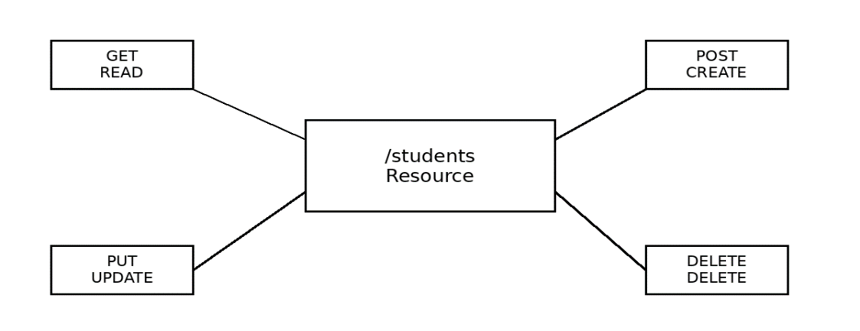

Figure 4: REST API and CRUD Operations

Relates GET, POST, PUT and DELETE to the basic CRUD operations.
Express Routes
A route tells Express what to do when a particular HTTP request reaches a particular URL. The HTTP method and URL together identify the operation.
app.get("/students", (req, res) => {
res.json(students);
});
Here, app.get() defines a GET route, /students is the URL path, req represents the incoming request and res is used to send the response.
GET – Reading Data
GET is used when a client wants to retrieve existing information from the server.
GET /students
app.get("/students", (req, res) => {
res.json(students);
});
GET with an ID
An identifier can be included in the URL when a particular record is required.
GET /students/5
For a route such as /students/:id, req.params.id contains the value supplied in the URL.
POST – Creating Data
POST sends new information to the server so that a new resource can be created. Data is normally placed in the request body as JSON.
POST /students
{
"name": "Asha",
"course": "CSE"
}
The request body can be accessed using req.body. For JSON requests, the Content-Type is commonly application/json.
PUT – Updating Data
PUT updates an existing resource. The URL identifies the resource and the request body contains the updated information.
PUT /students/2
{
"course": "CSE"
}
DELETE – Removing Data
DELETE removes an existing resource. The resource identifier is normally included in the URL.
DELETE /students/2
Complete REST API Example
GET /students → Read student data
GET /students/2 → Read student 2
POST /students → Create a new student
PUT /students/2 → Update student 2
DELETE /students/2 → Delete student 2
The HTTP method matters along with the URL. GET /students and POST /students use the same resource URL but perform different operations.

4. API Testing using Postman
Introduction to API Testing
API testing checks whether an Application Programming Interface works as expected. Requests are sent directly to the server and the returned status code, headers and response body are verified. Figure 5 shows the flow of sending an API request through Postman and inspecting the server response.
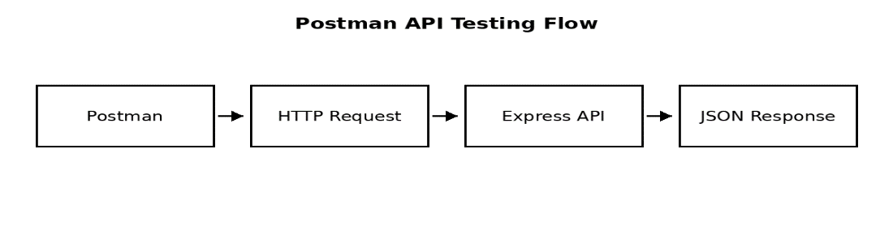

Figure 5: Postman API Testing Flow

Postman and API Requests
Postman provides an interface for creating, sending and inspecting API requests. The main parts of a request are the method, URL, headers and body.
• Method – GET, POST, PUT or DELETE specifies the operation.
• URL – identifies the API endpoint.
• Headers – provide additional request information such as Content-Type.
• Body – carries data sent to the server, commonly as JSON.

GET Request
Select GET, enter the endpoint, click Send and inspect the returned status code and JSON response.
GET http://localhost:3000/students
POST Request
POST creates a new resource. In Postman, select POST, enter the endpoint, choose Body → raw → JSON, enter the data and click Send.
POST http://localhost:3000/students
{
"name": "Riya",
"course": "CSE"
}
PUT Request
PUT updates an existing resource. Enter the resource ID in the endpoint and provide the updated JSON data in the request body.
PUT http://localhost:3000/students/2
{
"course": "CSE"
}
DELETE Request
DELETE removes an existing resource. After sending the request, inspect the status code and response.
DELETE http://localhost:3000/students/2
Inspecting JSON Responses
JSON is a common response format because it is easy for people and programs to read. Check the response body, status code and returned values. Figure 6 shows Common API testing responses.
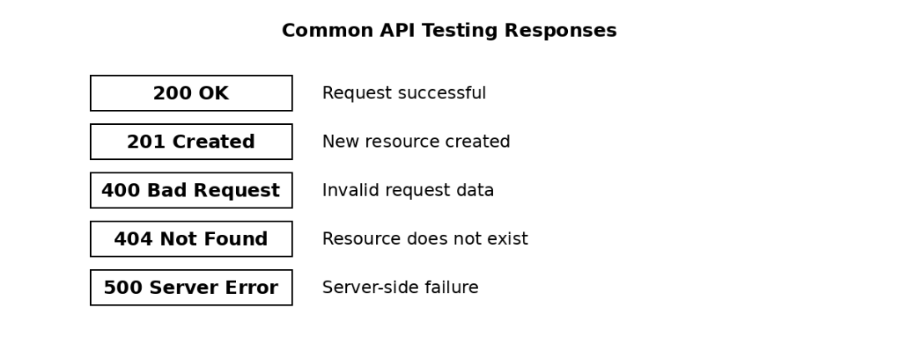

Figure 6: Common API Testing Responses
Error Testing
• Use an invalid URL or resource ID and verify the 404 Not Found response.
• Send incomplete or invalid data and inspect the returned error.
• Check that the response status code matches the result of the operation.

SKILL LAB MODULE-4

Database Fundamentals

1. Why Databases?
Databases provide an organized way to store, manage, search, and update application data. They reduce dependence on scattered files and make information easier to access and maintain. They support multiple users and applications while providing mechanisms for security and data integrity.
2. SQL vs NoSQL

  - SQL / Relational: predefined table structure, rows and columns, relationships commonly represented using keys, and SQL-based querying.
  - NoSQL / Non-relational: flexible data models, often suited to semi-structured or changing data and horizontally scalable applications.
  - MongoDB: document database; related data can be represented in a document using nested documents and arrays when appropriate.
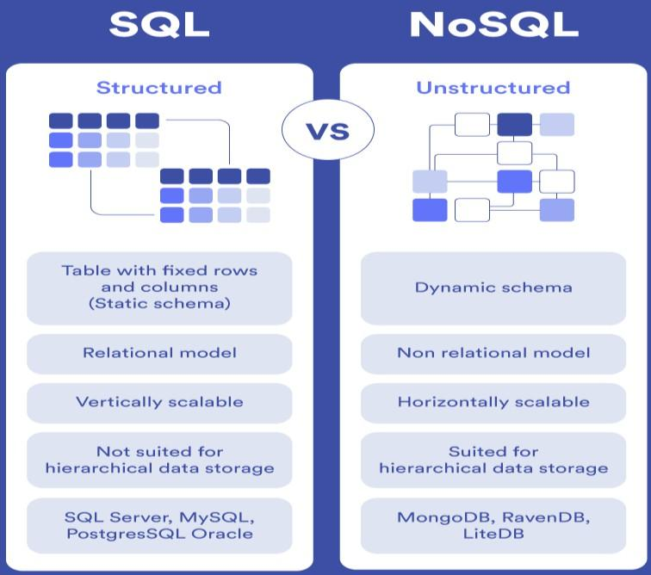

Figure 1: SQL vs NoSQL Database

3. MongoDB Concepts
MongoDB is a NoSQL document database designed to store application data as documents. Documents are stored in collections, and collections are stored within databases. MongoDB documents use field-and-value pairs and are stored internally as BSON, a binary representation related to JSON.
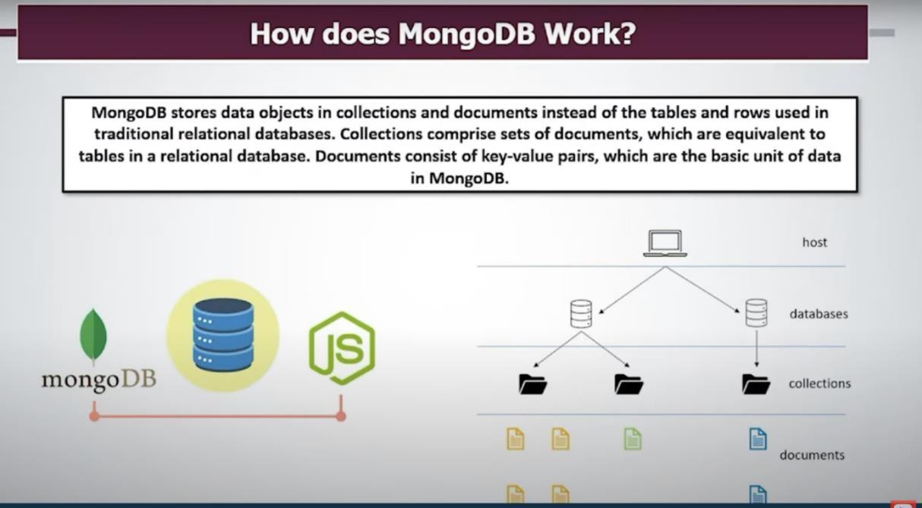
Figure 2: MongoDB hierarchy and document-oriented storage model

MongoDB hierarchy: Database → Collection → Document → Fields / Values
  - Database: logical container for one or more collections.
  - Collection: group of related MongoDB documents; broadly comparable to a table in a relational database.
  - Document: individual MongoDB data record represented as field-and-value pairs.
  - Field: a named value within a document, such as name, semester, or branch.

- Database and Collection
A MongoDB database is a logical container that holds one or more collections. It provides a namespace in which related application data can be organized. A database can be selected in mongosh using the use command, and collections can then be created or populated. For the skill-lab exercise, students will use a database such as CollegeDB to store student information.
use CollegeDB show dbs
A collection is a group of related documents within a MongoDB database.
A collection can be created explicitly with create Collection (), or MongoDB can create it when data is first inserted.
For this skill lab, the students collection will hold student documents used by the application.
db.createCollection ("students") show collections

Example structure: CollegeDB → students → student documents

- Document
A document is the basic unit of data stored in MongoDB. It consists of field-and-value pairs and can contain nested documents and arrays. Each standard MongoDB document has a unique _id field; MongoDB can generate an ObjectId automatically when one is not supplied.
Documents in the same collection can have flexible structures, although applications normally define a consistent structure for the data they manage.
Example Student Document
{
"name": "Rahul",
"usn": "1CS23CS001",
"semester": 3,
"branch": "CSE"
}
Explanation of fields:
- name – stores the student name.
- usn – stores the unique university/college identifier used for the student record.
- semester – stores the current semester as a numeric value.
- branch – stores the academic branch, such as CSE.
- A collection can therefore contain many student documents, for example one document for Rahul, another for Priya, and so on.

- CRUD Operations
CRUD stands for Create, Read, Update, and Delete, the four basic operations used to manage stored data.
Create inserts new documents into a collection, while Read retrieves documents using queries and filters.
Update modifies existing documents, and Delete removes documents that are no longer required.
MongoDB provides methods such as insertOne (), find(), updateOne(), and deleteOne() for these operations.

Basic MongoDB examples
// CREATE
db.students.insertOne({name:"Rahul", usn:"1CS23CS001", semester:3, branch:"CSE"})
// READ
db.students.find({branch:"CSE"})
// UPDATE
db.students.updateOne({usn:"1CS23CS001"}, {$set:{semester:4}})
// DELETE
db.students. deleteOne({usn:"1CS23CS001"})

- MongoDB Installation and Configuration
Download and Install
  - Go to the MongoDB Download Center and select Community Server, your version, Windows x64, and package MSI.
  - Double-click the downloaded .msi file to launch the setup wizard.
  - Click Next, accept the license agreement, and choose the Complete setup type.

Service Configuration
  - Select Install MongoDB as a Service
  - Keep Run service as Network Service user as the default setting.
  - Note the default Service Name (MongoDB) and the default data and log directories.
  - Leave Install MongoDB Compass checked if you want a graphical interface.
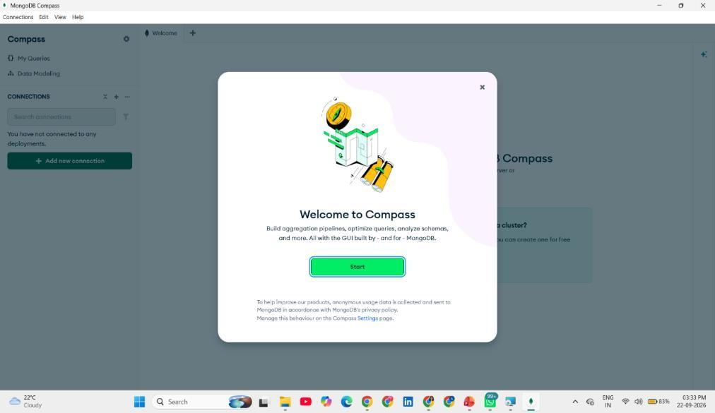
  - Click Next and then Install.

Figure 3: Welcome Page of MongoDB after installation
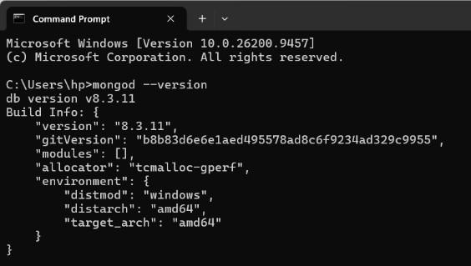

Figure 4: Verifying Installation of MongoDB

8. Install MongoDB Shell (mongosh)
  - MongoDB no longer bundles the interactive shell by default.
  - Download and install the separate MongoDB Shell (mongosh).
  - Add the path to mongosh.exe to your Windows PATH Environment Variable during installation.
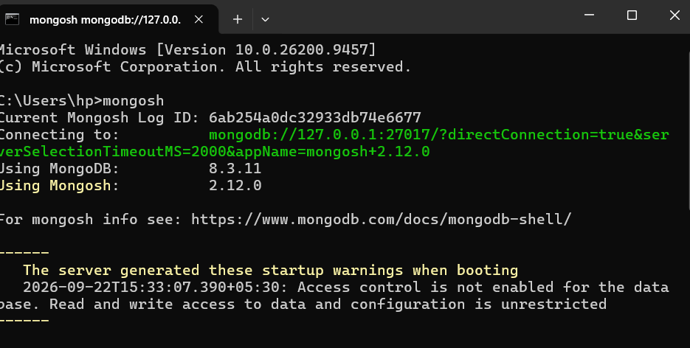

Figure 5: Verifying installation of MongoDB Shell
a. MongoDB Hands-on
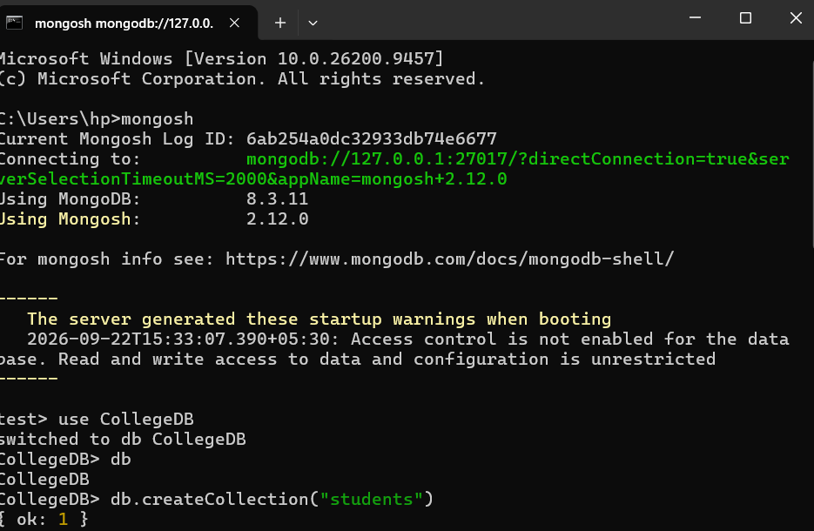
Figure 6: Connecting to MongoDB using Mongosh

This figure shows the MongoDB Shell (mongosh) being launched from the Windows Command Prompt. The shell establishes a connection to the local MongoDB server through the local host address.

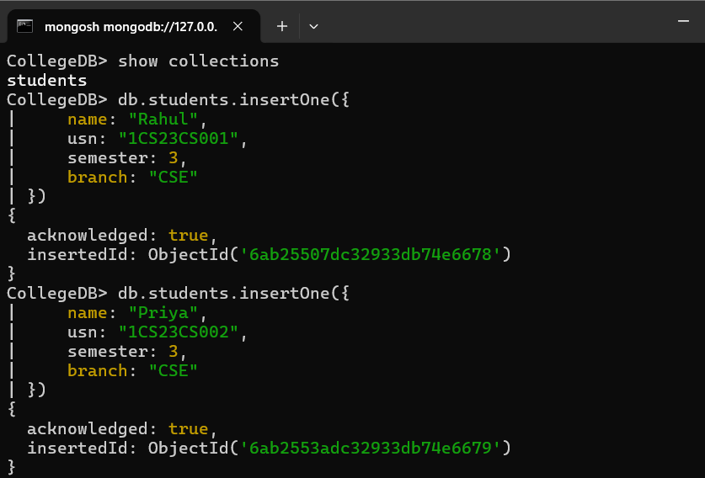

Figure 7: Creating a Database and Collection

The figure demonstrates the creation/use of a database named CollegeDB. The command: use CollegeDB - switches to the specified database.
The figure then uses:
db.createCollection("students") - to create a collection named students.
The successful response confirms that the collection creation operation was completed.
Figure 8: Inserting Student Documents
The figure shows multiple student documents being inserted into the students collection using the insert One () method.
Each document contains fields such as:
  - name
  - usn
  - semester
  - branch
The MongoDB shell displays an acknowledged response and generates an insertedId for each inserted document.
b. Connect Backend with Database
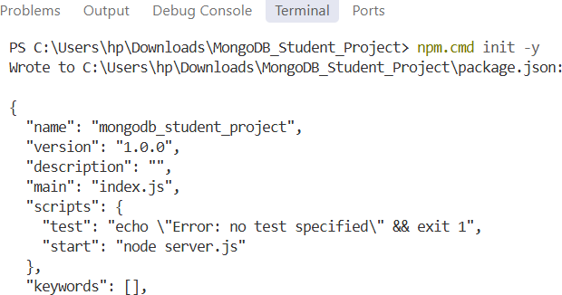

Figure 9: Initializing a Node.js MongoDB Project
The figure shows a project being created for MongoDB application development using Node.js. The npm init -y command generates a package.json file containing project information such as the project name, version, main JavaScript file, and scripts.
This shows installation of the Express and MongoDB packages using npm.
Finally, node server.js is executed, showing that the application has successfully connected to MongoDB and is running on port 3000.

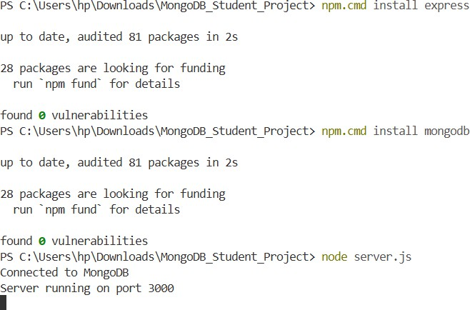

Figure 10: Node.js Server Connected to MongoDB
The figure provides a closer view of the Node.js project initialization and package installation process. The terminal output confirms that the required packages are installed and that the server starts successfully.
The messages “Connected to MongoDB” and “Server running on port 3000” indicate successful connectivity between the Node.js application and MongoDB.

Figure 11: Initializing a Node.js Project

Figure 12: Sending Requests Using Postman
The figure shows the Postman interface being used to interact with the locally running student-management application. A request is sent to the local server through an HTTP endpoint.
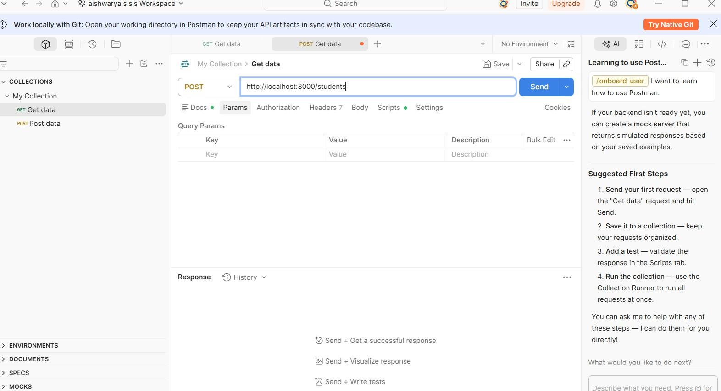
The interface contains the request method, URL, request body, and response area.

Figure 13: API Request and Response
This figure demonstrates different HTTP methods being selected in Postman, such as GET, POST, PUT, PATCH, and DELETE. The request is sent to the application endpoint and the response from the server is displayed in the response section.

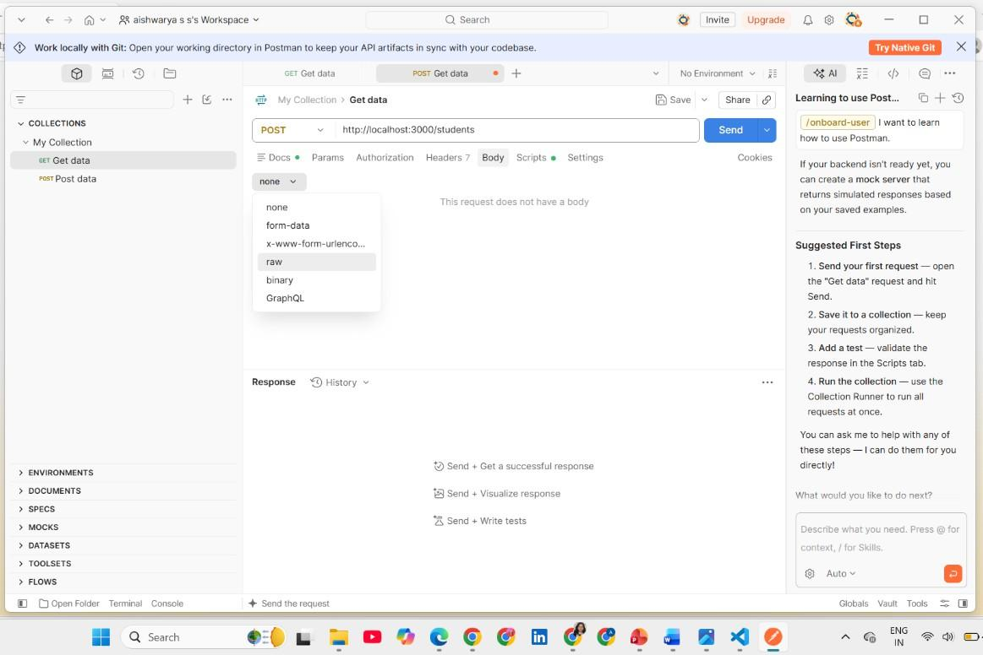
Figure 14: MongoDB Application Code and API Testing
The figure combines the application source code in Visual Studio Code with the API testing interface. The source code contains routes for interacting with student data, while the API client is used to send requests and observe the resulting responses.
Purpose:
It demonstrates the connection between the backend implementation and API testing, showing how requests received by the application can interact with MongoDB data.

c. Frontend + Backend + Database
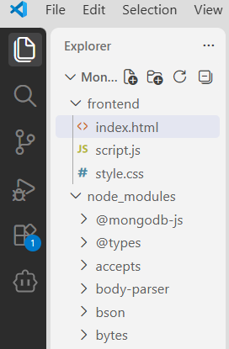
Figure 15: Project Structure in VS Code
The figure shows the project structure in Visual Studio Code. The project contains a frontend directory with files such as:
- index.html
- script.js
- style.css
It also shows the node_modules directory and MongoDB-related dependencies.
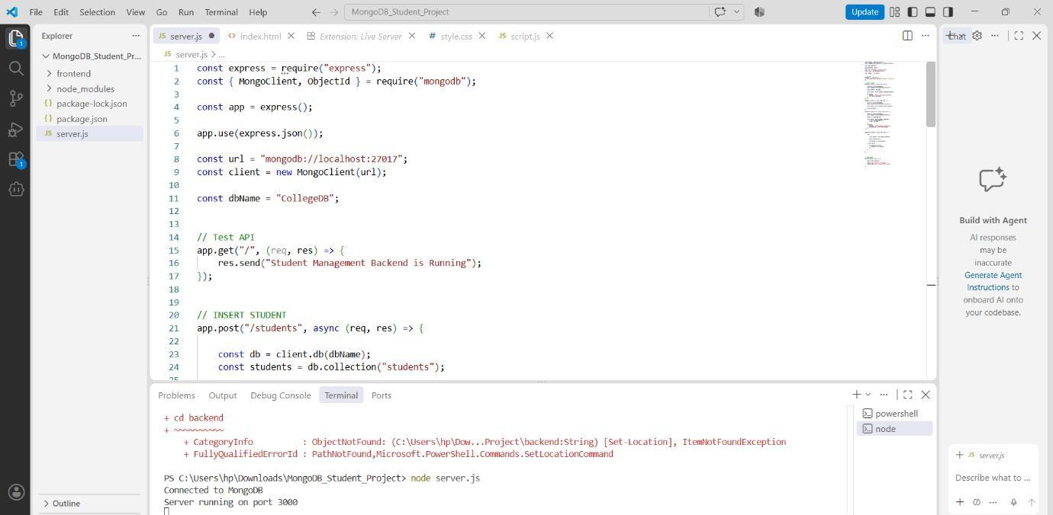

Figure 16: Student Management System Interface
The interface contains an Add Student section with fields for entering student information. It also contains a Student List section and a button to view the stored student records.
This shows the application source files and execution environment
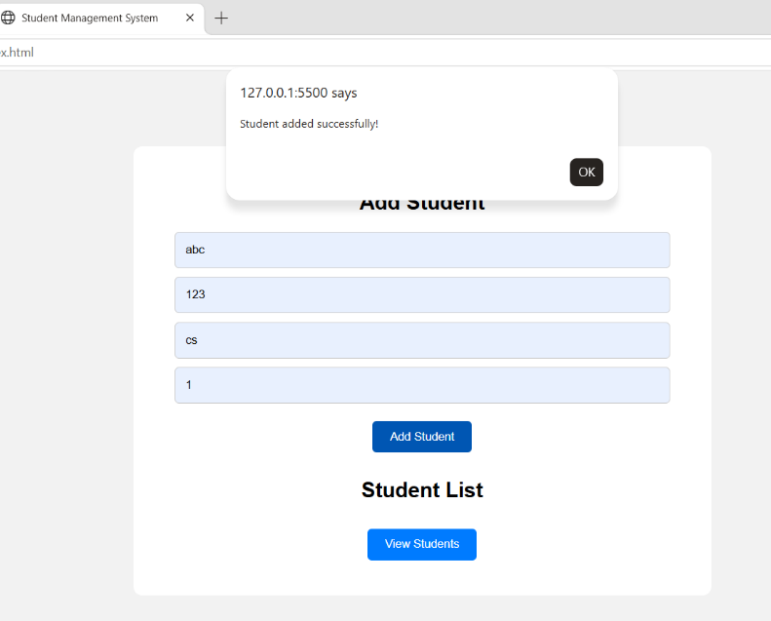

Figure 17: Adding Student Data Successfully
The figure shows the application after student information has been entered and submitted. A confirmation message indicates that the student was added successfully. The entered information is subsequently displayed in the student-management interface.
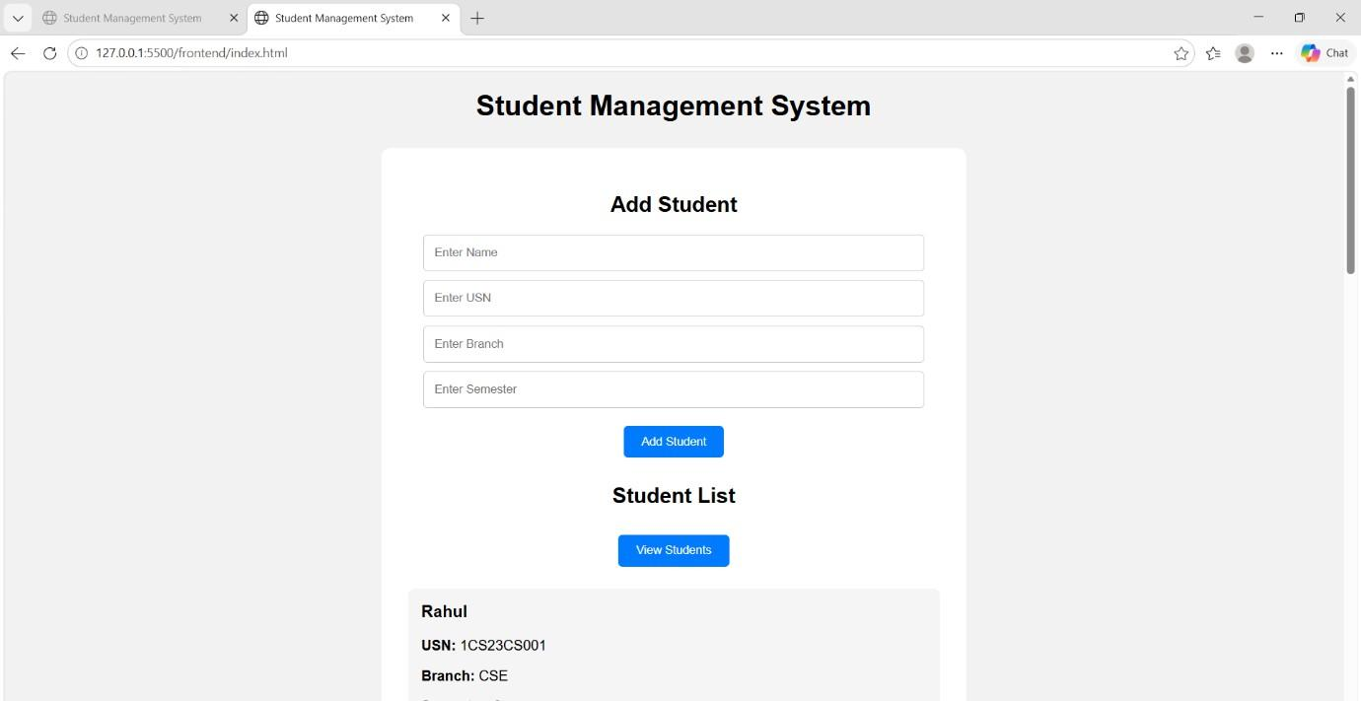
Figure 18: Viewing Student Data
This demonstrates the complete data-entry operation, from submitting student details through the frontend to receiving confirmation from the backend application.

9. Viva Questions

1. What are the three main components of a student management system?
2. What is the role of index.html in the project?
3. What is the purpose of script.js?
4. What is the purpose of style.css?
5. What is the role of the backend in this application?
6. Why is MongoDB used in this project?
7. What is an API?
8. What is the purpose of the fetch () function in JavaScript?
9. What is the difference between GET and POST methods?
10. Which HTTP methods are used for CRUD operations?
11. What happens when you click the Add Student button?
12. What happens when you click the View Students button?
13. How does the frontend communicate with MongoDB?
14. What does “Server running on port 3000” mean?
15. Explain the complete data flow when a student is added to the system.
16. What is the purpose of Node.js in this project?
17. Why is Express.js used in the backend?
18. What information is stored in a student document?
19. What is the purpose of the node_modules folder?
20. How can you verify that the student data has been successfully stored and retrieved?

SKILL LAB MODULE-5

GIT - GIT HUB Basics

1. Git - A distributed version control system
A version control system (often called a source code control system) does these things:
- Keeps multiple (older and newer) versions of everything (not just source code)
- Requests comments regarding every change
- Allows “check in” and “check out” of files so you know which files someone else is working on
- Displays differences between versions
2. Benefits of version control
For working by yourself:
- Gives you a “time machine” for going back to earlier versions
- Gives you great support for different versions (standalone, web app, etc.) of the same basic project
For working with others:
- Greatly simplifies concurrent work, merging changes
3. Git vs GitHub
Git is a free and open source distributed version control system designed to handle everything from small to very large projects with speed and efficiency
GitHub is a web-based Git repository hosting service, which offers all of the distributed revision control and source code management (SCM) functionality of Git as well as adding its own features.
4. Installation and setup
- https://git-scm.com/install/windows (for windows machines)
- https://git-scm.com/install/mac (for macOS machines)
- https://git-scm.com/install/linux (for linux machines)
Once the Git is installed on computer, there will be a need to customize Git environment. After installation of Git, we have to do a few things to customize our Git environment. These things(set identity, set Editor, check personal setting, get help) should be only once on any given computer; they’ll stick around between upgrades. You can also change them at any time by running through the commands again. Git comes with a tool called git config that lets you get and set configuration variables that control all aspects of how Git looks and operates. Things include set identity, set editor, check personal setting, get help.
a. Setting Identity:
The first thing that should be done after Git installation is to set user name and email address. This is important because every Git commit uses this information, and it’s immutably baked into the commits you start creating:
git config --global user.name <"username">
git config --global user.email <email-id>
b. Setting editor:
The next thing that should be done is to configure the default text editor that will be used when Git needs you to type in a message. If not configured, Git uses your system’s default editor. To use different text editor on Windows such as Notepad or Notepad++ use the following command:
git config --global core.editor “C:/Program Files/Notapad++/Notepad.exe (in windows)
c. Check Setting:
To check settings, use the git config --list command to list all the settings Git can find at that point:
git config --list
user.name=<username>
user.email=<email-id>
color.status=auto
color.branch=auto
color.interactive=auto
color.diff=auto ...
d. Get help:
There are three ways to get the manual page (manpage) help for any of the Git commands:
git help <verb>
git <verb> --help
man git-<verb>
For example, you can get the manpage help for the config command by running
git help config
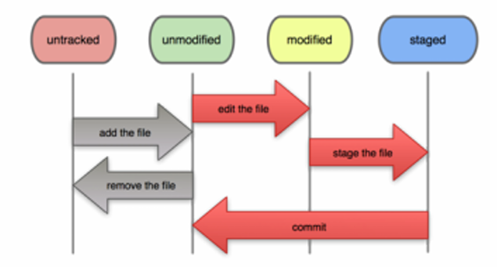
e. Basic Workflow
Fig.1 Git basic workflow

Git Commands
git init
– create git project in existing directory
git add <filename>
- add files to be committed. git add takes the snapshot of the file that will be
Committed. You can change the file after adding it.
git commit
-create a commit (a “snapshot”) of added files
git status
-to check the current status of your working tree
git reset HEAD <filename>
-to unstage a file, but retain your changes in the working tree
git checkout -- <filename>
-to discard current changes in the working tree, and make it look like the last
commit
git rm <filename>
-to remove a file from the working tree and in the next commit
git rm --cached <filename>
-to remove it from the next commit, but keep the file in the working tree
git diff HEAD
-to view differences of files
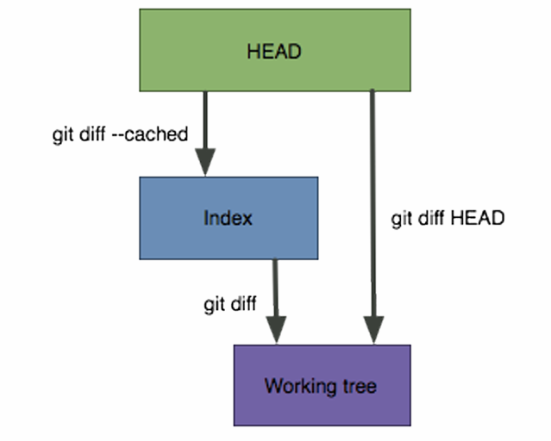

Fig. 2 Overview of git diff command

5. The .gitignore file
- Specifies files that you don’t want Git to track under version control
- Commonly used for compiled files, binaries, large asset files (e.g. images)
- Can use wildcards (e.g. *.pyc, *.png, Images/*, etc.)
- You can create a .gitignore file in your repository's root directory to tell Git, which files and directories to ignore when you make a commit.
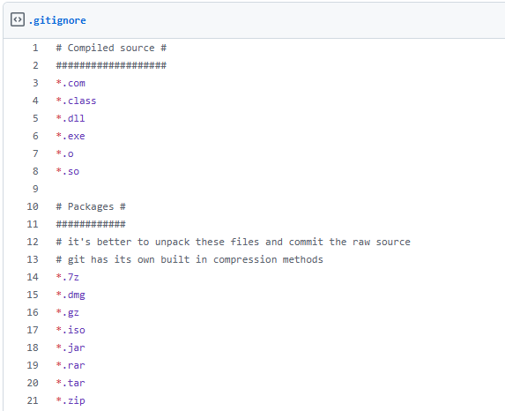
Fig. 3 Snapshot of .gitignore file
6. Fundamentals of GitHub
Introduce yourself to GitHub
- Register on GitHub
https://github.com/
- Authenticating to GitHub Desktop
https://help.github.com/desktop/guides/getting-started/authenticating-to-github/
- Configuring Git for GitHub Desktop
https://help.github.com/desktop/guides/getting-started/configuring-git-for-github-desktop/

Command | Description
fetch/clone | to download a full copy of a repository's data from GitHub.com, including all versions of every file and folder.
pull | a request to merge changes from one branch into another.
push | to upload your local commits to GitHub
checkout | command is a core Git utility used to switch between branches, navigate to specific commits, or restore files in your working directory
add | command is used to save changes from your working directory into your Git staging area, preparing them to be committed and eventually pushed to GitHu
commit | command saves a permanent snapshot of your staged changes to your local project history
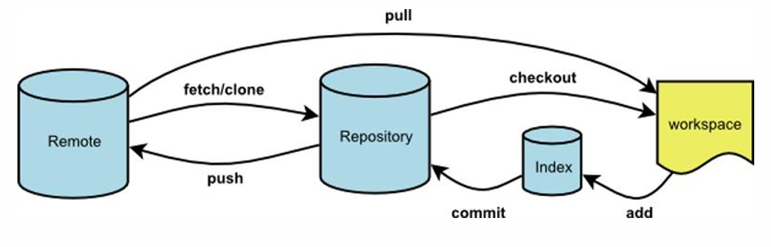
Fig. 4 GitHub Workflow
Create or add a repository to GitHub
https ://help.github.com/articles/create-a-repo/
From GitHub Desktop, then Publish to GitHub
https://help.github.com/desktop/guides/contributing/adding-a-repository-from-your-local-computer-to-github-desktop/
Commit your changes on GitHub
From GitHub Website
https://help.github.com/articles/create-a-repo/
From GitHub Desktop
https://help.github.com/desktop/guides/contributing/committing-and-reviewing-changes-to-your-project/
Creating a branch for your work
A branch is a parallel version of the main line of development in the repository, or the default branch (usually master). Use branches to
- Develop features
- Fix bugs
- Safely experiment with new ideas
From the GitHub Website
https://help.github.com/articles/creating-and-deleting-branches-within-your-repository/
From the GitHub Desktop
https://help.github.com/desktop/guides/contributing/creating-a-branch-for-your-work/
Synchronizing your branch
As commits are pushed to your project on GitHub, you can keep your local copy of the project in sync with the remote repository https://help.github.com/desktop/guides/contributing/syncing your-branch/
Revert your commit
If you change your mind about a commit after you create it, you can revert the commit. When you revert to a previous commit, the revert is also a commit. In addition, the original commit remains in the repository's history.
https://help.github.com/desktop/guides/contributing/reverting-a-commit

7. E-Commerce Platform
A web-based application where users can buy and sell products online, featuring a feature-rich UI with sections for order history, categorized products, search bar, profile, login/logout, and secure payments. Inspired by platforms like Amazon and Flipkart, it handles transactions and data records efficiently with MERN stack.
Tech Stack
- Frontend: React.js or Angular for a dynamic and responsive UI.
- Backend: Node.js with Express for handling API requests and processing transactions.
- Database: MongoDB for flexible, document-based data storage.
- Other: Stripe or PayPal API for payment processing, JWT for user authentication, Docker for containerization, Redis for caching.
Learning Outcomes
- Full-stack development with MERN
- API design and transaction processing
- Secure payment integration
- Authentication and containerization
- Building scalable e-commerce applications
- Ed-Tech App
A comprehensive tutorial app inspired by the rise of online education post-COVID, offering pre-recorded sessions (free or paid), video/content-based courses for school, college, or specialized domains. Built with MERN/MEAN stack, it enhances skills while contributing to accessible learning for students and professionals.
Tech Stack
- Frontend: React.js or Vue.js for an interactive learning platform
- Backend: Node.js with Express or Django for managing courses and video streaming
- Database: PostgreSQL or MongoDB for storing user data and course information
- Other: Amazon S3 or Firebase for storing videos, JWT for secure login sessions, WebRTC for live video sessions
Learning Outcomes
- Full-stack development with MERN/MEAN
- Video streaming and storage integration
- Authentication, authorization, and payment systems
- Real-time features using WebRTC
- Building scalable, user-centric applications for social impact
- Social Media App
A feature-rich, efficient, and secure social media platform similar to Instagram or Facebook, with millions of users in mind. Includes chatting, profile viewing, uploading pictures/content/videos, and robust data management for large-scale storage.
Tech Stack
- Frontend: React Native for mobile-friendly UI; Bootstrap or Tailwind CSS for styling
- Backend: Node.js with Express or Django for API handling and data storage
- Database: MongoDB for user profiles, posts, and messages
- Other: Socket.io for real-time messaging, AWS for media storage, OAuth for social login options, Redis for caching
Learning Outcomes
- Real-time communication with Socket.io
- Mobile-first development with React Native
- Large-scale data management
- Media storage and OAuth integration
- Secure, scalable social platforms
- Gaming App
A multiplayer card game app like UNO for 3-4 players, where each gets 7 cards and aims to discard them first to win. Backend stores player data and learns from past games, providing fun learning through real-time interaction.

Tech Stack
- Frontend: Unity or Phaser for graphics rendering, or React Native for mobile-based games
- Backend: Node.js with Express or Python (Django) for game logic and leader board management
- Database: MongoDB for storing game state and user data
- Other: WebSockets for real-time multiplayer interaction, Firebase for data sync
Learning Outcomes
- Game logic and multiplayer synchronization
- Real-time WebSockets implementation
- Graphics rendering with Unity/Phaser
- Data syncing and leaderboards
- Engaging, interactive gaming applications

- Data Analytics App
An app for managing and segregating data by category, with UI for data entry, login/logout, and backend for precise DBMS handling. Inspired by COVID data challenges, it visualizes and analyzes datasets effectively.
Tech Stack
- Frontend: D3.js and React for interactive data visualization
- Backend: Python with Flask or Django for data processing, or Node.js
- Database: PostgreSQL or MongoDB for data storage, or BigQuery for large datasets
- Other: Pandas for data analysis, Matplotlib for graphing, Apache Spark for big data handling, OAuth for authentication
Learning Outcomes
- Data visualization with D3.js
- Big data processing with Pandas/Spark
- Interactive dashboards
- Secure data handling and analysis
- Scalable analytics platforms
- Food Delivery App
A mobile-compatible app like Zomato or Swiggy, featuring food item lists, search bar, cart, and payment methods. Beginners can start with frontend; advanced users add full functionality for orders and tracking.

Tech Stack
- Frontend: React Native or Flutter for mobile compatibility
- Backend: Node.js with Express or Django to handle order processing and delivery tracking
- Database: MongoDB or Firebase for storing user, order, and restaurant data
- Other: Google Maps API for delivery tracking, Stripe for payment processing, Twilio for SMS notifications
Learning Outcomes
- Cross-platform mobile development
- Order processing and tracking APIs
- Payment and notification integration
- Geolocation with Google Maps
- User-friendly delivery applications
- Project Management App (Trello)
A task management app like Trello with a dashboard for pending, ongoing, and completed sections. Users move tasks, set timers, and track progress to smoothen company workflows and impress recruiters.
Tech Stack
- Frontend: React or Angular for a responsive user interface, D3.js for data visualization
- Backend: Node.js with Express or Python (Flask) for task tracking and user management
- Database: PostgreSQL or MongoDB to store project and user information
- Other: JWT for user authentication, Web Socket for real-time updates, Firebase for notifications, Chart.js for data visualization
Learning Outcomes
- Real-time task updates with Web Sockets
- Responsive UI and visualization
- User authentication and notifications
- Project tracking systems
- Collaborative management tools
- Portfolio Website
An online showcase of achievements, milestones, and skills with create/edit/delete posts, image uploads for certificates. Represents your professional journey and adds value to resumes.
Tech Stack
- Frontend: HTML, CSS, JavaScript; Next.js for a server-rendered React application
- Backend: Node.js or PHP for form submissions and content management
- Database: SQLite or MongoDB for storing user data
- Other: Netlify or GitHub Pages for deployment, CMS like Contentful or Sanity for easier content management
Learning Outcomes
- Server-side rendering with Next.js
- Content management systems
- Deployment on Netlify/GitHub Pages
- Form handling and media uploads
- Personal branding websites
- Content Management System
A system like WordPress for creating, editing, and publishing content with drag-and-drop interfaces, text/images/videos, and templates. Stores data in database for easy website building.
Tech Stack
- Frontend: React or Angular for building a responsive dashboard interface
- Backend: Node.js with Express, Django, or PHP for handling content operations
- Database: MySQL or PostgreSQL for content storage, Redis for caching
- Other: AWS S3 for media storage, CKEditor or TinyMCE for rich text editing, JWT for authentication
Learning Outcomes
- Rich text editing integration
- Drag-and-drop UI components
- Content storage and caching
- Media management with AWS S3
- Scalable CMS development
16. Job Application
A job search app with database of postings, filters by criteria, company integrations, and application tracking. Fun project connecting seekers with vacancies for personalized job hunting.
Tech Stack
- Frontend: Vue.js or Angular for an interactive job search UI
- Backend: Django or Node.js with Express for handling job listings and applications
- Database: PostgreSQL or MongoDB for storing job postings and user applications
- Other: LinkedIn API for professional profile integration, Elasticsearch for advanced search functionality, Google Maps for job location display
Learning Outcomes
- Advanced search with Elasticsearch
- API integrations like LinkedIn
- Interactive filtering UIs
- Geolocation job displays
- Job portal development
17. Grocery Delivery App
A convenient app like Zepto or Blinkit with categorized items (packed, fruits, sweets), order history, payments, and tracking. Saves time for busy users with minimal or advanced features.
Tech Stack
- Frontend: React Native for a mobile-friendly interface
- Backend: Django or Node.js with Express to handle orders, inventory, and delivery
- Database: MongoDB or MySQL for managing product data and user information
- Other: Firebase for push notifications, Stripe for payments, Google Maps API for tracking deliveries
Learning Outcomes
- Inventory and order management
- Push notifications with Firebase
- Payment and tracking integrations
- Mobile grocery interfaces
- E-commerce delivery systems
18. Work-Out Tracker
A health app like FitBit for tracking heart rate, footsteps, workouts, with comparisons, reminders, alarms, and scheduling. Dashboard visualizes daily progress for better fitness management.
Tech Stack
- Frontend: React Native or Flutter for cross-platform mobile support
- Backend: Django or Node.js for managing user data and workout sessions
- Database: MongoDB or Firebase for user progress tracking
- Other: Fitbit API or HealthKit for syncing fitness data, JWT for user authentication, Chart.js for data visualization
Learning Outcomes
- Fitness API syncing
- Cross-platform mobile apps
- Data visualization with Chart.js
- User authentication and reminders
- Health tracking applications
19.Viva Questions
- What is a Git repository?
- How does Git work?
- What is Git add?
- What is Git status?
- What is a commit in Git?
- What is branching in Git?
- What is a conflict in Git?
- What is merge in Git?
- What is a remote in Git?
- How do you revert a commit that has already been pushed and made public?
- What is Git stash?
- What is Git reflog?
- How do you make an existing Git branch track a remote branch?

